Inverse square law
Objective

To explore the relationship between the distance from a radioactive source and the intensity of radiation

Apparatus
Radiographic imaging system, Ionization chamber (GM(Geiger-Muller) tube detector), Tape measure.

Theory
X-rays are emitted isotropically (i.e., with equal intensity in all directions) from the target of the x-ray tube. The anode and diagnostic housing prevent x-rays from exiting in any direction other than through the window of the tube and port of the housing. The collimator or other beam-restricting devices further define the useful x-ray beam.
The intensity of the x-ray beam decreases as the square of the distance from the source increases. If the distance from the source is doubled, the intensity will be reduced to one fourth its former value. This relationship, known as the inverse square law, is based solely on geometry. It has nothing to do with x-ray absorption.
The x-ray intensity (I₁) passing through a unit area at some distance (d_{l}) from the target will be
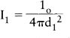
where I₀ is the total number of x-rays emitted from the target. The intensity (I₂) at any other distance (d₂) from the target will similarly be as follows:

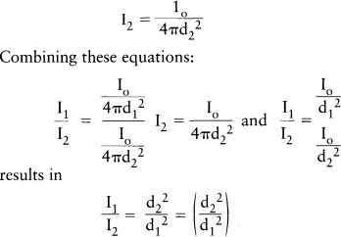

𝐼𝑥 = 𝐼1 (
𝑑1 2
)

𝑑2

N α ¹
𝑑2

The inverse square law (ISL) expresses the relationship between distance and intensity (quantity) of radiation and governs the dose received. The law is stated as "The intensity of radiation is inversely proportional to the square of the distance from the source."

Procedures
- The x-ray imager may be used as it is normally filtered. Record the total filtration present if known.
- Set the tube potential to 70 kVp. This will remain constant throughout the experiment.
- Locate the position of the source (the target) of x-rays. Many tube housings are marked at the position of the target; if not, assume the target position to be at the middle of the tube housing.
- Position the ionization chamber on the central ray of the useful beam and as close to the source as possible.

- Record this distance on the data sheet provided and take three readings of intensity. If possible, the mA and exposure time should remain constant throughout this experiment. However, if the response range of the ionization chamber will not accommodate such measurements; either or both may require adjustment.
- Repeat these measurements at approximately 25 cm intervals to a distance of 200 cm from the source.
- Express the radiation intensity as exposure rate (mR/mAs) at each distance by use of the following expression:
Exposure rate (mR/mAs) = Exposure (mR) / Tube current (mA) exposure time(s)
- Plot exposure rate (mR/mAs) as a function of distance from the source (cm)

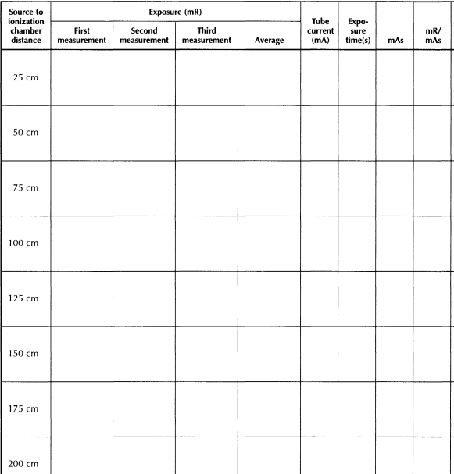

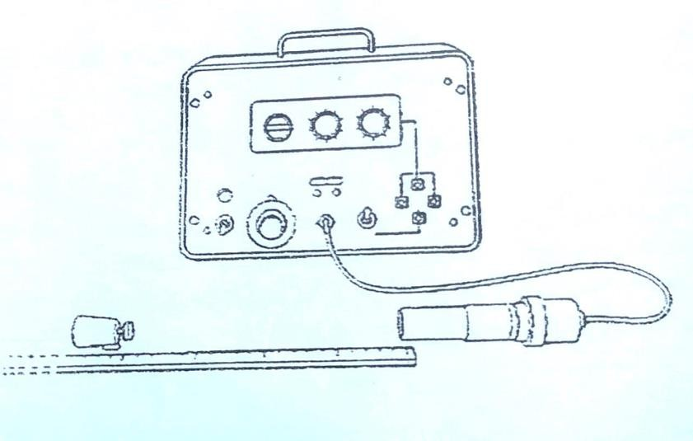

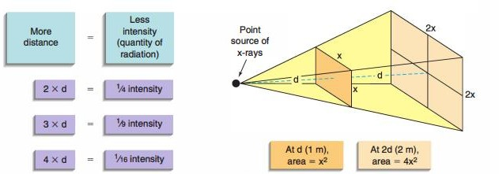

Worked Example
The exposure rate from a fluoroscopic X-ray machine is 5 R/min at 50 cm. What would be the exposure rates at (i) 40 cm, and (ii) 60 cm?
𝐼1 = 5 R/min, 𝑑1 = 50 cm, 𝑑2= 40 cm, 𝐼𝑥 = ?

𝐼 = 𝐼 (𝑑1)
2
𝑥 1 𝑑2

= 5 R/min × (50 cm/40 cm)²
= 7.81 R/min
𝐼1 = 5 R/min, 𝑑1 = 50 cm, 𝑑2 = 60 cm, 𝐼𝑥 = ?
𝐼𝑥 = 5 R/min × (50 cm/60 cm)²
= 3.47 R/min

