Basic principles of CT image
The X-ray tube and detector array be interconnected and rotated the around the patient during the survey period. Then assemble the data that is obtained in digital computers and integrate it to reconstruct a digital image of the cross section to provide a cross sectional image (tomogram) that is displayed on a computer screen.
- 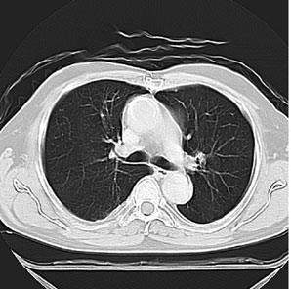Human body is imagined as a matrix and is divided into number of columns and rows. In general, 512 or 1024 columns and rows are used
Each matrix element is named as picture element (pixel) in a 2- dimensional (2D) concept. Volume element (voxel) represents a volume of tissue in the patient and it is a three dimensional (3D) concept.
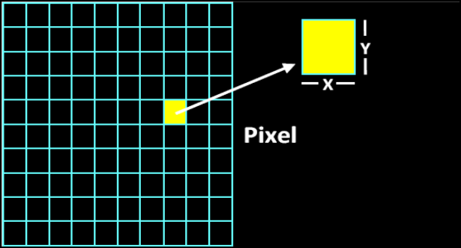
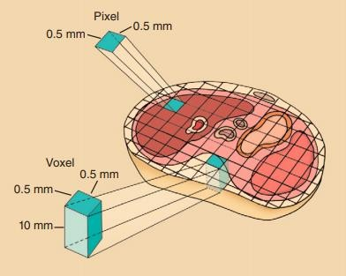

Pixel size = FOV / Matrix size
Example: Compute the pixel size for the characteristics of CT images: FOV 200 cm, 128 × 128 matrix
Pixel size = 200mm / 128 pixels = 1.6 mm/pixel
- In addition, in a real CT image, all tissues within a single pixel would be the same shade of gray.

CT Image
The measurements are reconstructed with the help of an algorithm and the final image is displayed on a TV monitor.
- An attenuation measurement quantifies the fraction of radiation removed in passing through a given amount of a specific material of thickness X
An X-ray beam which is transmitted through a voxel, is given by the relation

where
I = I₀ e^{–μx}

- I and I_{o} are the x-ray intensities measured with and without the material in the x-ray beam path, respectively,
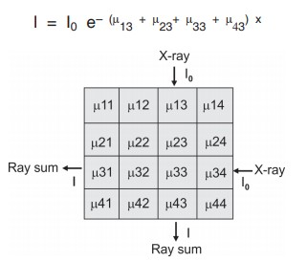
- μ is the linear attenuation coefficient of the specific material.

The formula above is expressed as the natural logarithm:
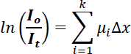

- The image reconstruction process, such as the filtered back-projection method and many other methods
- The image reconstruction process derives the average attenuation coefficient (μ) values for each voxel in the cross section by using many rays from many different rotational angles around the cross section.
- The specific attenuation of a voxel (μ) increases with the density and the atomic numbers of tissues averaged through the volume of the voxel and declines with increasing x-ray energy.

Hounsfield unit (CT number)
Radiology uses a special unit, now called Hounsfield unit (HU). The Hounsfield unit is dimensionless. The Hounsfield density of tissues reflects their attenuation of x-ray and is proportional to their physical density
- The precise CT number of any given pixel is related to the x-ray attenuation coefficient of the tissue contained in the voxel. The value of a CT number is given by the following:
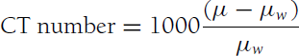
Where
  - µ is the attenuation coefficient of the tissue in the voxel under analysis,
  - µ_{w} is the x-ray attenuation coefficient of water and
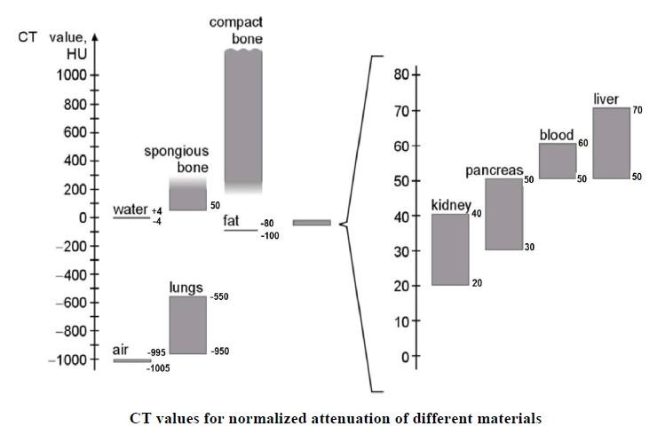
  - CT numbers are called Hounsfield Units (HU)

- Each pixel is displayed on the monitor as a level of brightness, which correspond to a range of CT numbers from -1000 to +3000.
- Voxels containing materials that attenuates more than water (e.g. muscle tissue, liver, and bone) have positive CT numbers, whereas materials with less attenuation than water (e.g. lung or adipose tissues) have negative CT numbers.

Windowing
Windowing is the process in which the CT image grayscale of a particular image can be adjusted via the CT numbers; doing this will change the appearance of the picture to highlight particular structures (certain anatomy or pathology).
- This is typically done by the technologist or radiologist to better demonstrate certain anatomy or pathology.
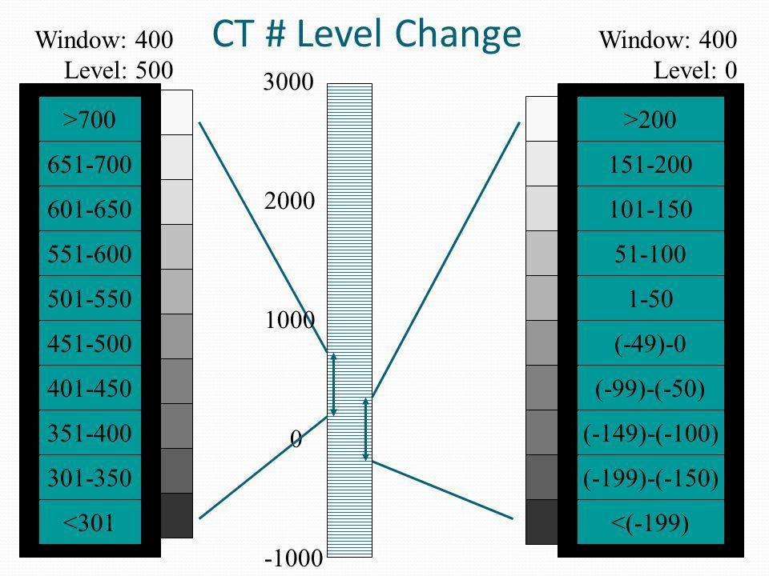

- The window width (WW) is the range of the grayscale that can be displayed.
- The center of grayscale range is referred to as the window level (WL).

- A large window width means there is a long grayscale and the transition black to white will take longer.
- A narrow window width means the transition from black to white will take place much faster

- The contrast is adjusted via the window width (WW).

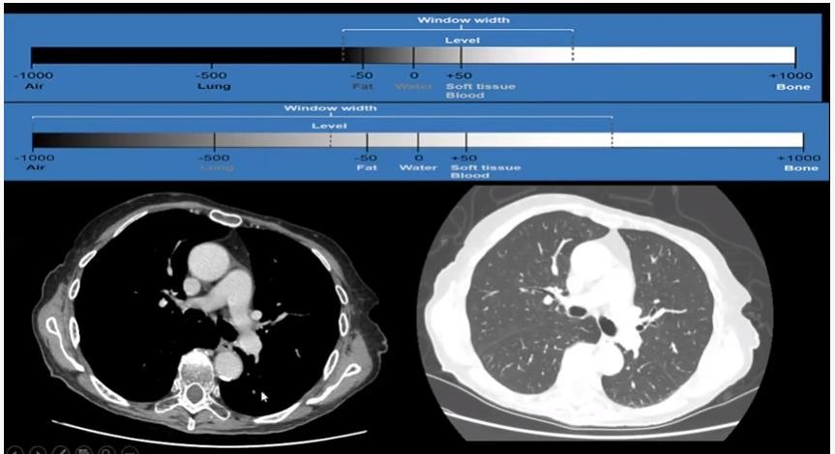

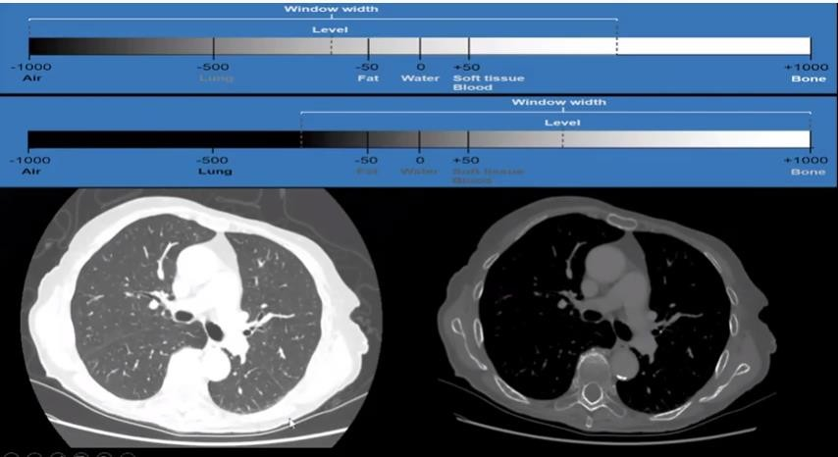
- The brightness of the image is adjusted via the window level (WL).

Water has a CT number of zero. The CT number for air is –1000 HU, since. The average CT value for blood is approximately +45 HU. Soft tissues (including fat, muscle, and other body tissues) have CT numbers ranging from –100 HU to 60 HU. Cortical bones are more attenuating and have CT numbers from 250 HU to over 1000 HU. The linear attenuation coefficient is magnified by a factor over 1000 (note the division by ).
Medical scanners typically work in a range of –1024 HU to +3071 HU.
- The density difference between soft tissues and air is great allowing, for example, the nasal airways to be clearly seen.
- Soft tissues and organs represent narrow Hounsfield value ranges and are therefore more difficult to differentiate between adjacent structures, such as between fat and muscle when viewing and segmenting CT data

