The x-ray tube

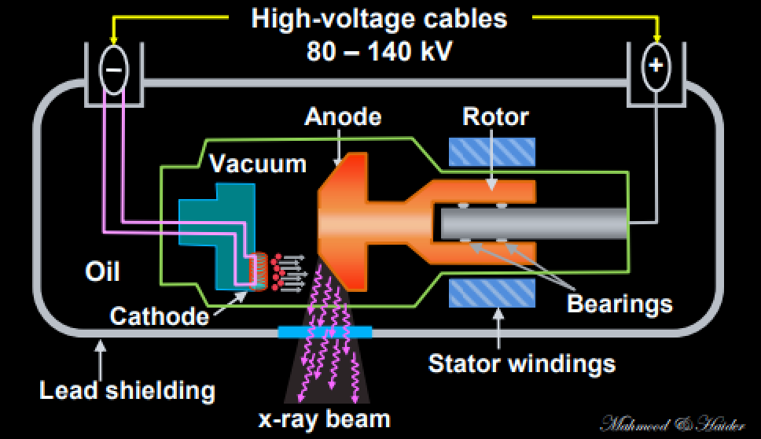

Figure (1): x-ray tube with a rotating anode and a heated filament.
We will look at each of the pieces of the x-ray tube and what they do to help with the production of x-ray
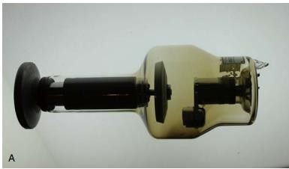

The cathode
- Filament, surrounded by a focusing cup
- The filament is approximately 2 mm in diameter and 1 or 2 cm long
- The filament (electron emitter) is usually a coiled wire filament 0.2–0.3 mm (e.g. tungsten)

- Focusing cup is used to focus the electrons on a small area (focal spot) in the anode.
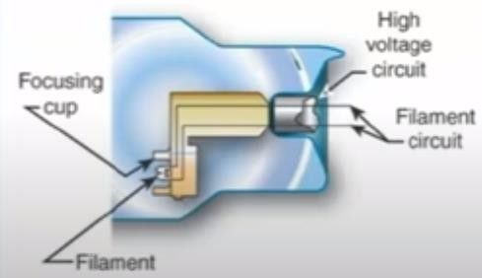

Figure: The cathode
Tungsten vaporization with deposition on the inside of the glass enclosure is the most common cause of tube failure

The Filaments
many x-ray tubes have two filaments (dual focus) so that the tubes can have a greater variety of exposures
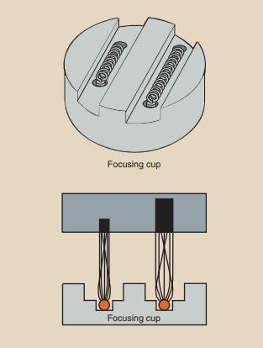
- When the small filament is activated, its electrons are directed to a tiny focal spot on the target.

- The small filament and focal spot provide finer image detail when a relatively small exposure is appropriate—for example, when imaging a small body part such as a toe or wrist
- The large filament provides more electrons and is aimed at a somewhat larger target area. The combination of large filament and large focal spot is used when a large exposure is required, such as for radiographs of the lumbar spine or the abdomen
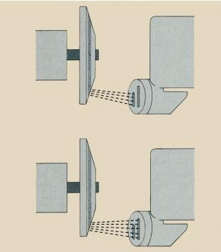

Figure: In a dual-focus x-ray tube, focal spot size is controlled by heating one of the two filaments.
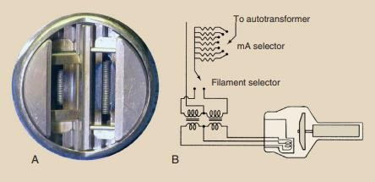

A- Dual-filament cathode designed to provide focal spots of 0.5 mm and 1.5 mm.
B- Schematic for a dual-filament cathode.
- The figure above shows the wiring for a dual tube. the autotransformer where you select the miliamperage for the filament. The filament selector is where the different filaments selected

Focusing Cup
The focusing cup controls the width of the electron distribution, and directs the electron toward the target
- Because all of the electrons accelerated from cathode to anode are electrically negative, the electron beam tends to spread out owing to electrostatic repulsion.
- Some electrons can even miss the anode completely.
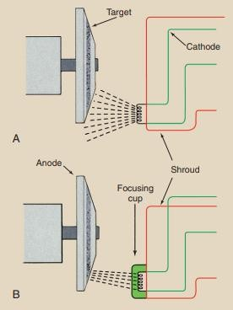
Space charge effect: When the applied kV is zero or small, the electrons surrounding the filament forms a cloud, resulting in space charge effect. As the kVp is increased, (0–40 kV) the effect of space charge reduces gradually and the tube current also increases.
Saturation: Above 40 kVp, the space charge effect is overcome, and the tube current is controlled by the filament current. This is called the saturation

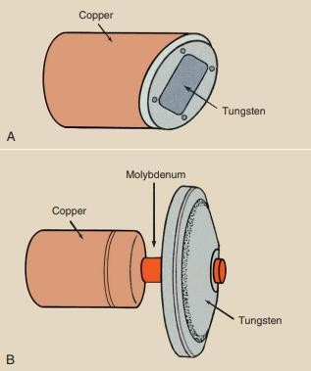
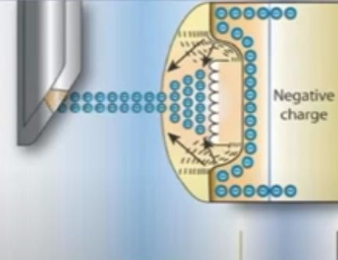
The Anode
There are two types of anodes, stationary and rotating
- Stationary anode x-ray tubes are used in dental x-ray imaging systems, some portable imaging systems, and other special-purpose units in which high tube current and power are not required
- General-purpose x-ray tubes use the rotating anode because they must be capable of producing high-intensity x-ray beams in a short time.
The anode is the target electrode, consists of stator and rotor which is maintained at a positive potential

Target
The target is the area of the anode struck by the electrons from the cathode. High-capacity x-ray tubes have molybdenum or graphite layered under the tungsten target.
- Both molybdenum and graphite have lower mass density than tungsten, making the anode lighter and easier to rotate.
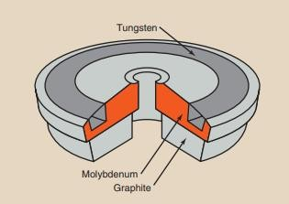

Specialty x-ray tubes for mammography have molybdenum or rhodium targets principally because of their low atomic number and low K-characteristic x-ray energy.

Stator and Rotor

How does the anode rotate inside an enclosure with no mechanical connection to the outside?
An induction motor consists of two principal parts separated from each other by the glass or metal enclosure.
- The part outside the glass or metal enclosure, called the stator, consists of a series of electromagnets equally spaced around the neck of the tube.
- Inside the enclosure is a shaft made of bars of copper and soft iron fabricated into one mass. This part is called the rotor
Current in each stator winding induces a magnetic field that surrounds the rotor. The stator windings are energized sequentially so that the induced magnetic field rotates on the axis of the stator. This magnetic field interacts with the ferromagnetic rotor, causing it to rotate synchronously with the activated stator windings.
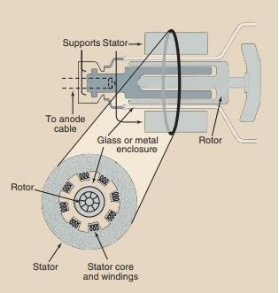
When the stator coils are energized, rotating magnetic field is produced.
Figure(4): The Anode

What is the purpose of anode?
- Serves as a target surface for the high-voltage electrons
- The anode is an electrical conductor
- The anode also must be a good thermal dissipater
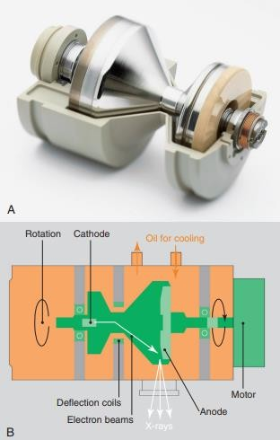

This very high capacity x-ray tube revolves in a bath of oil for complete heat dissipation
The electron beam is deflected electromagnetically onto the anode. The cooling oil is in contact with the back of the anode, allowing optimum cooling.
- The principal advantages are improved heat dissipation and greater capacity

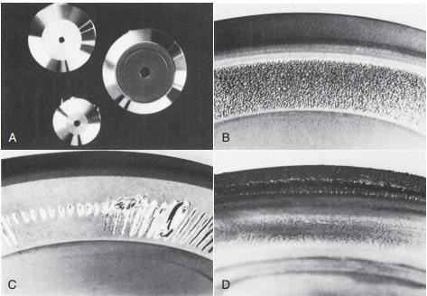

Comparison of smooth, shiny appearances of rotating anodes when new
- versus their appearance after failure (B–D).
- Examples of anode separation and surface melting shown were caused by slow rotation caused by bearing damage,
- repeated overload,
- and exceeding of maximum heat storage capacity.

