In an x-ray tube, the projectile is the electron. All electrons have the same mass; therefore, electron kinetic energy is increased by raising the kVp
- At 100 mA, for example, 6 × 10¹⁷ electrons travel from the cathode to the anode of the x-ray tube every second.
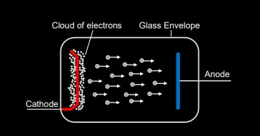

- When these projectile electrons hit the heavy metal atoms of the x-ray tube target, they transfer their kinetic energy to the target atoms.
The projectile electron interacts with the orbital electrons or the nuclear field of target atoms. These interactions result in the conversion of electron kinetic energy into thermal energy (heat) and electromagnetic energy in the form of infrared radiation (also heat) and x-rays.
- Approximately 99% of the kinetic energy of projectile electrons is converted to heat.
- The production of heat in the anode increases directly with increasing x-ray tube current
- Heat production also increases directly with increasing kVp
  - Interaction with the outer shell electrons of an atom generating heat.
  - Interaction with the inner shell electrons or the nuclei themselves generating X-rays
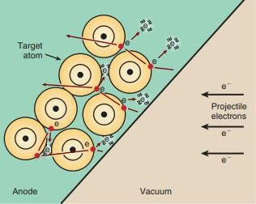

X-ray photons produced by an X-ray tube are heterogeneous in energy. There are two types of X-ray spectrum, namely-:
(a) continuous spectrum and (b) characteristic spectrum.

Characteristic Radiation
Characteristic x-rays result when the interaction is sufficiently violent to ionize the target atom through total removal of an inner-shell electron.
- Characteristic x-rays are emitted when an outer-shell electron fills an inner-shell void. Figure below illustrates how characteristic x-rays are produced.
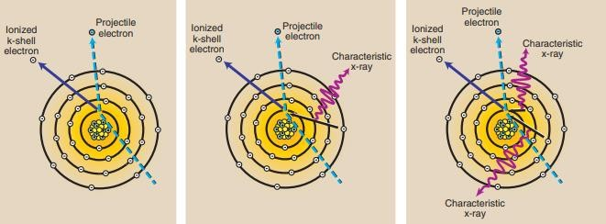

Question:
A K-shell electron is removed from a tungsten atom and is replaced by an L-shell electron. What is the energy of the characteristic x-ray that is emitted?
K-shell electrons have binding energies of 69 keV, and L-shell electrons are bound by 12 keV.
Therefore, the characteristic x-ray emitted has energy of 69 − 12 = 57 keV.
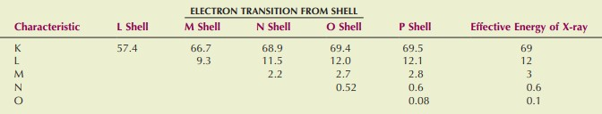
- Only the K-characteristic x-rays of tungsten are useful for imaging.

- the Kα radiation has photon energy; E_{K} − E_{L} = 58 keV
- the Kβ radiation has photon energy; E_{K} − E_{M} = 67 keV
This type of x-radiation is called characteristic because it is characteristic of the target element.

Bremsstrahlung or continuous Radiation
Bremsstrahlung x-rays are produced when a projectile electron is slowed by the nuclear field of a target atom nucleus.
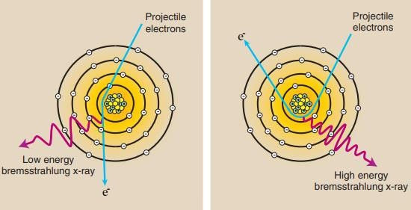
A projectile electron that completely avoids the orbital electrons as it passes through a target atom may come sufficiently close to the nucleus of the atom to come under the influence of its electric field (Figure below). Because the electron is negatively charged and the nucleus is positively charged, there is an electrostatic force of attraction between them
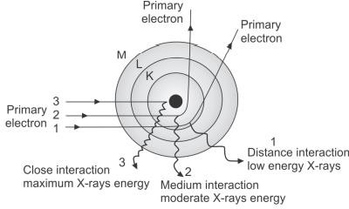

  - The closer the projectile electron gets to the nucleus, the more it is influenced by the electric field of the nucleus
  - The maximum amount of energy that can be emitted equals the kV. This is rare: It occurs when an electron is completely stopped by this braking force

Bremsstrahlung x-rays have a range of energies and form a continuous emission spectrum
The maximum energy (in keV) of a bremsstrahlung x-ray is numerically equal to the kVp of operation
  - In the diagnostic range, most x-rays are bremsstrahlung x-rays
  - At 100 kVp, approximately 15% of the x-ray beam is characteristic, and the remaining is bremsstrahlung

X-ray Spectrum (Characteristic and Bremsstrahlung)
The relative intensity of the K x-rays is greater than that of the lower energy characteristic x-rays because of the nature of the interaction process.
K x-rays are the only characteristic x- rays of tungsten with sufficient energy to be of value in diagnostic radiology
Characteristic x-rays have precisely fixed (discrete) energies and form a discrete emission spectrum.

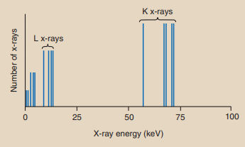

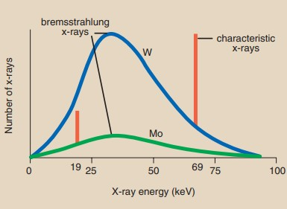

The bremsstrahlung spectrum is much lower because the atomic number of Mo is low (Z = 42), and x-ray production is much less efficient. A line extends above the curve at 19 keV to represent the K-characteristic x-rays of molybdenum.

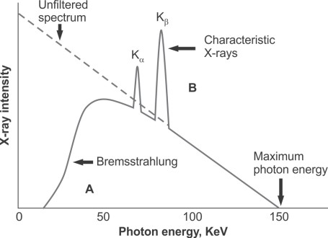

What is the λmin , Emax and ʋmax in x-ray spectra?
X-ray energy is inversely proportional to its wavelength. As x-ray wavelength increases, x-ray energy decreases
E = hʋ ʋ = c/λ E= hc / λ
E = 1.24 / λ λ = 1.24 / E
The minimum wavelength of x-ray emission corresponds to the maximum x-ray energy, and the maximum x-ray energy is numerically equal to the kVp.
K.E = eV Emax = hʋmax
= hc / λ_{min} = eV
K.E = E_{max} = eV

(Quizzes examination No. 1)
Calculate the: -
1-maximum energy
&
2- minimum wavelength
for an x-ray beam generated at 100 kVp.

