Line-focus Principle
The line-focus principle describes the relationship between the actual and the effective focal spots in an x-ray tube, where the electrons in the tube current bombard the target, and the effective focal spot, which is the same area as seen from directly below the tube.

Focal spot
The focal spot is the area of the target from which x-rays are emitted.
The effective target area, or effective focal spot size, is the area projected onto the patient and the image receptor
The actual focal spot size refers to the size of the area on the anode target that is exposed to electrons from the tube current. It depends on the size of the filament producing the electron stream.
- When the target angle is made smaller, the effective focal spot size also is made smaller.
- Diagnostic x-ray tubes have target angles that vary from approximately 5 to 20 degrees
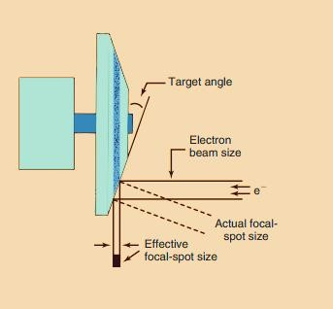
Figure 1: The line-focus principle allows high anode heating with small effective focal spots. As the target angle decreases, so does the effective focal spot size.
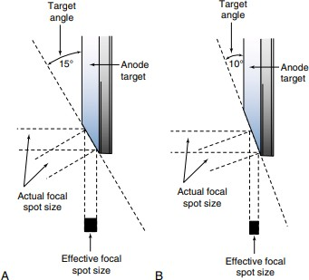

- Both actual focal spot sizes are the same, meaning that they can withstand the same heat loading. The smaller effective focal spot results in improved image quality.
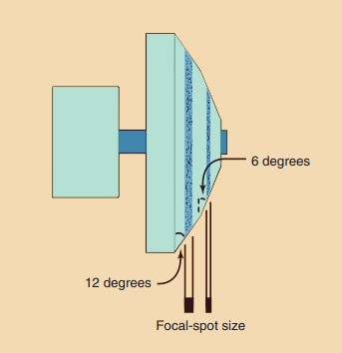Some targets have two angles to produce two focal spots. To achieve this, the filaments must be placed one above the other.
The effective focal spot depends on
  - Actual focal spot size
  - Target angle

The heel effect
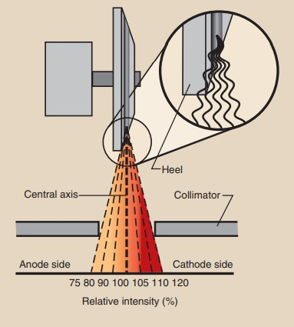
Describe as varying radiation intensity across the x-ray field in the anode– cathode direction caused by attenuation of x-rays in the heel of the anode.

Figure 2: The heel effect results in reduced x-ray intensity on the anode side of the useful beam caused by absorption in the “heel” of the target

(The reason) the intensity of x-rays that are emitted through the “heel” of the target is reduced because they have a longer path through the target and therefore increased absorption. This is the heel effect.
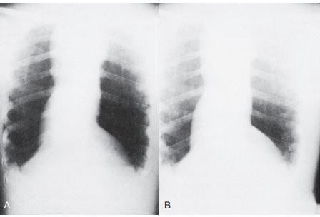
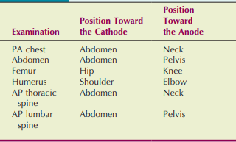Patient Positioning for Examinations That Can Take Advantage of the Heel Effect

The heel effect can be used to advantage in radiography because the cathode end of the tube can be placed over a thicker body part, resulting in a more even exposure to the
image receptor.

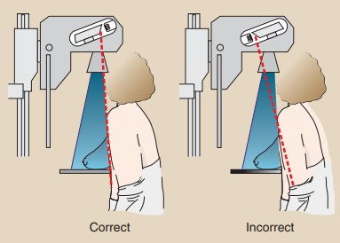The heel effect is important to mammography. The conic shape of the breast requires that the radiation intensity near the chest wall must be higher than that to the nipple side to ensure near-uniform exposure of the image receptor. This is accomplished by positioning the cathode to the chest wall

Figure3: The heel effect can be used to advantage in mammography by positioning the cathode toward the chest wall to produce a more uniform optical density

Protective X-ray Tube Housing
Every x-ray tube must be contained within protective housing that reduces leakage radiation during use.
- Leakage radiation is that radiation emitted from the x-ray tube housing in all directions other than that of the useful beam
- Leakage radiation must be less than 100 mR/hr (1 mGya/hr) at a distance of 1 m from the protective housing, while the tube operates at maximum output
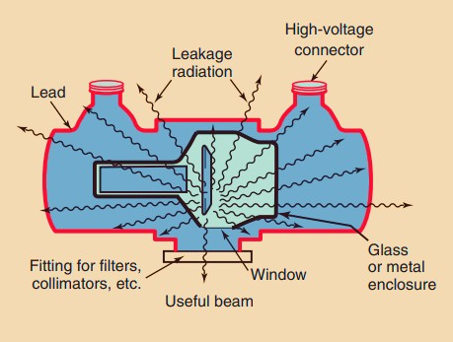
Figure 4: Protective housing reduces the intensity of leakage radiation to less than 1 mGya/hr at 1 m.

Off-Focus Radiation
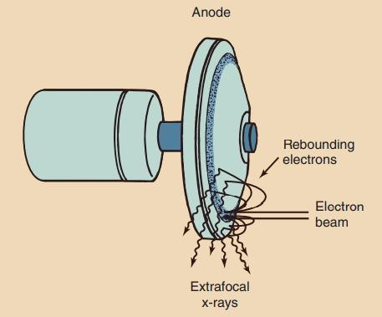Some of the electrons bounce off the focal spot and then land on other areas of the target (see figure 5), causing x-rays to be produced from outside of the focal spot

Figure 5: Extrafocal x-rays result from interaction of electrons with the anode off of the focal spot.
off-focus radiation can image patient tissue that was intended to be excluded by the variable-aperture collimators.

- Off-focus radiation is reduced by designing a fixed diaphragm in the tube housing near the window of the x-ray tube (Figure 5). This is a geometric solution.
