Filtration
Objective

Define filtration and know its purpose and type and can it improve image quality
Apparatus
x-ray machine, different thickness of Al filters, dosimeter.
Theory
Filtration X-ray imaging systems have metal filters, usually 1 to 5 mm of aluminum (Al). The purpose of these filters is to reduce the number of low-energy x-rays.
Low-energy x-rays contribute nothing useful to the image. They only increase the patient dose unnecessarily because they are absorbed in superficial tissues and do not penetrate to reach the image receptor.
- Adding filtration to the useful x-ray beam reduces patient dose.
- Increasing filtration increases the quality of an x-ray beam
Almost any material could serve as an x-ray filter. Al (Z = 13) is chosen because it is efficient in removing low-energy x-rays through the photoelectric effect and because it is readily available, Lightweight, inexpensive, and easily shaped.
Copper (Z = 29), tin (Z = 50), gadolinium (Z = 64), and holmium (Z = 67) have been used sparingly in special situations. As filtration is increased, so is beam quality, but quantity is decreased.
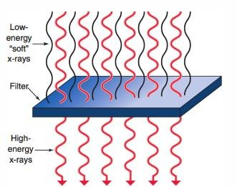

Effect of Filtration on the Absorbed Dose to the Patient. If adequate filtration were not present, very low energy photons (20 keV or lower) would enter the patient and be almost totally absorbed in the body, thus increasing the patient's radiation dose, especially near or at the surface, but contributing nothing to the image process.

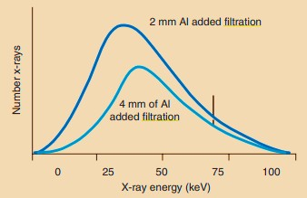
Figure 1:Adding filtration to an x-ray tube results in reduced x-ray intensity but increased effective energy.

Types of Filtration
Filtration of diagnostic x-ray beams has two components: inherent filtration and added filtration.
Inherent filtration: The glass or metal enclosure of an x-ray tube filters the emitted x-ray beam.
The inherent filtration of a general purpose x-ray tube is approximately 0.5 mm Al equivalent.
- With age, inherent filtration tends to increase because some of the tungsten metal of both the target and filament is vaporized and is deposited on the inside of the window.
Added Filtration: A thin sheet of Al positioned between the protective x-ray tube housing and the x-ray beam collimator is the usual form of added filtration.
- The addition of a filter to an x-ray beam attenuates x-rays of all energies emitted, but it attenuates a greater number of low-energy x-rays than high- energy x-rays. This shifts the x-ray emission spectrum to the highenergy side,

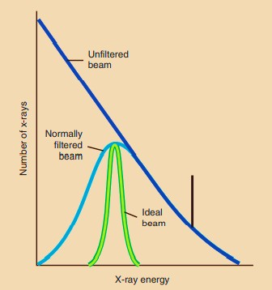resulting in an x-ray beam with higher energy, greater penetrability, and better quality.
Figure 2: Filtration is used selectively to remove lowenergy x-rays from the useful beam. Ideal filtration would remove all low-energy x-rays.
  - Added filtration usually has two sources. First, 1-mm or more sheets of Al are permanently installed in the port of the x-ray tube housing between the housing and the collimator.
  - 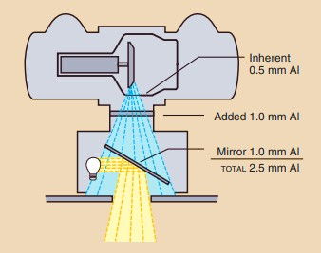With a conventional light-localizing variable-aperture collimator, the collimator contributes an additional 1 mm Al equivalent added filtration (figure 2). This filtration results from the silver surface of the mirror in the collimator

Figure 2: Total filtration consists of the inherent filtration of the x-ray tube, an added filter, and filtration achieved by the mirror of the light-localizing collimator.

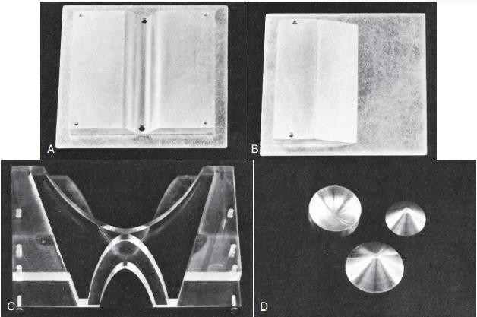Compensating filters can be fabricated for many procedures; therefore, they come in various sizes and shapes. They are nearly always constructed of Al, but plastic materials also can be used. Figure 3 shows some common compensating filters.
Figure 3: Compensating filters. A, Trough filter. B, Wedge filter. C, “Bow-tie” filter for use in computed tomography. D, Conic filters for use in digital
fluoroscopy.

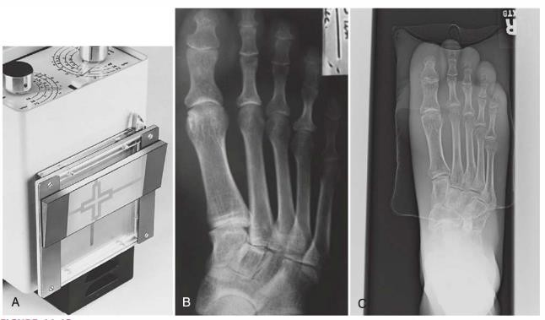
(B) a dorsoplantar projection of the foot without a compensating filter. (C) A dorsoplantar projection of the foot with a wedge-shaped lead-acrylic compensating filter.

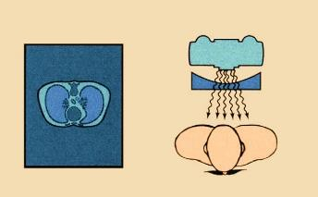

Figure 4: Use of a trough filter for examination of the chest.
A step-wedge filter is an adaptation of the wedge filter (Figure 4).
- usually when long sections of the anatomy are imaged with the use of two or three separate image receptors
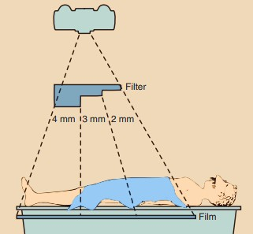
Figure 4:Arrangement of apparatus with the use of an aluminum step-wedge for serial radiography of the abdomen and lower extremities.

Procedures
- Determine the total filters thickness of the x-ray tube
- Determine the x-ray beam intensity with no added filters material in the beam
- Put some added filters to the x-ray beam
- Determine the new x-ray beam intensity with the added filters material in the beam
- Change the x-ray device techniques and notice the change in radiation quantity and quality of the x-ray beam using the dosimeter, Discuss the result
Inherent filters: dosimeter readings: µsv
Added filters: dosimeter readings: µsv Total filters:

