Ministry of Higher Education and Scientific Research AL Mustaqbal university college
Chemical Engineering Department

Petroleum Properties Laboratory
2^{nd.} Stage.

Exp. No.5
Say bolt Viscosity Test

Supervised by
Asst.lect. Ban Ali Hassan

2021-2022

Aim:
Aim of this work : empirical procedures for determining say bolt viscosity of petroleum products at specified temperatures between 21 and 990 C.

Main principles :

Say bolt viscosity - Efflux time in seconds of 60 ml. of sample flowing through a calibrated orifice under specified condition.
a. Say bolt Universal Viscosity “SUV”
Determined using an orifice of (1.76 ± 0.015) mm in diameter used for lubricants and distillates with efflux time greater than 32 sec. and less than 1000 sec. The viscosity value is reported in Say bolt Universal seconds, abbreviated SUS, at a specified temperature.
b. Say bolt Furol Viscosity “SFV”
Determined using an orifice of (3.15 ± 0.02) mm in diameter used when “SUV” value is greater than 1000 sec. The viscosity value is reported in Say bolt Furol seconds, abbreviated SFS, at a specified temperature. The “SFV” is approximately one tenth the “SUV”.

Introduction :
The viscosity of a fluid is an important property in the analysis of liquid behavior and fluid motion near solid boundaries.
The viscosity is the fluid resistance to shear or flow and is a measure of the adhesive/cohesive or frictional fluid property. The resistance is caused by intermolecular friction exerted when layers of fluids attempt to slide by one another.
In simple terms, viscosity is a measure of a fluid's resistance to flow. The knowledge of viscosity is needed for proper design of required temperatures for storage, pumping or injection of fluids.
There are two related measures of fluid viscosity - known as dynamic (or absolute) and kinematic viscosity.
This test can be used to determine the Saybolt Universal Viscosity or Saybolt Furol (fuel and road oils) Viscosity and then kinematic viscosity of asphalt emulsions. This covers the empirical procedures for determining the viscosities of petroleum products at specified temperatures between 21 and 990 C.
In this test method, the efflux time in seconds of 60 ml sample, flowing through a calibrated orifice, measured under carefully controlled conditions. This time is corrected by an orifice factor and reported as the viscosity of the sample at that temperature.

Theory:
Crude oil is categorized by the property of the liquid, with viscosity, API gravity, density, amount of water and suspended solid matter it contains. These properties vary by the refining of crude oil.
Three tests will be done on a refined oil to measure the viscosity. The density of the crude oil will be determined in this lab using a specific gravity relation, an API Gravity relation and the usage of a densitometer. All tests were done following the ASTM standard.
Saybolt Viscometer
The first test used is the Saybolt Viscometer. This test is done by measuring the time it takes for a fixed volume of oil to flow down, with only gravity acting on it. The time measured from the Saybolt Viscometer is in Saybolt Universal Seconds (SUS).
The viscosity, in centistokes can be calculated using this equation:
η = 0.22θ – 180 / θ when, 30 < θ < 500
Or
η = 0.216θ when, θ > 500
Where: η = viscosity in centistokes
θ = viscosity in SUS

And the absolute viscosity can be calculated with this equation:
μ = η ρ
Where: μ = absolute viscosity in centipoise
ρ = density in gm/cc

Viscosity changes indirectly with temperature and this can be dictated from the Walther equation:
Log (Log (η + 0.8)) = - n Log (T / T₁) + Log (Log (η₁ + 0.8))
Where: η = kinematics viscosity, in centistokes at temperature T
T = absolute temperature in Kelvin, or Rankine
η₁ = viscosity at Temperature T₁
n = constant for a given liquid

For this lab, the relation between temperature and viscosity will be related using the viscosity index. This is calculated using the viscosity of two temperature, 100˚F and 210˚F. The viscosity index is calculated with this equation:
V.I = (L-U) / (L-H) x 100
Where: U = Kinematic Viscosity at 100˚F of the oil whose viscosity is to be calculated
L = Kinematic Viscosity at 100˚F of an oil with a zero viscosity index which has the same viscosity at 210˚F as the oil whose viscosity index is being calculated
H = Kinematic Viscosity at 100˚F of an oil with viscosity index of 100 which has the same viscosity at 210˚F as the oil whose viscosity index is being calculated
All U, L, and H have units of Saybolt Universal Seconds.

Requirements:
- Saybolt Viscometer test assembly as fig. (1)

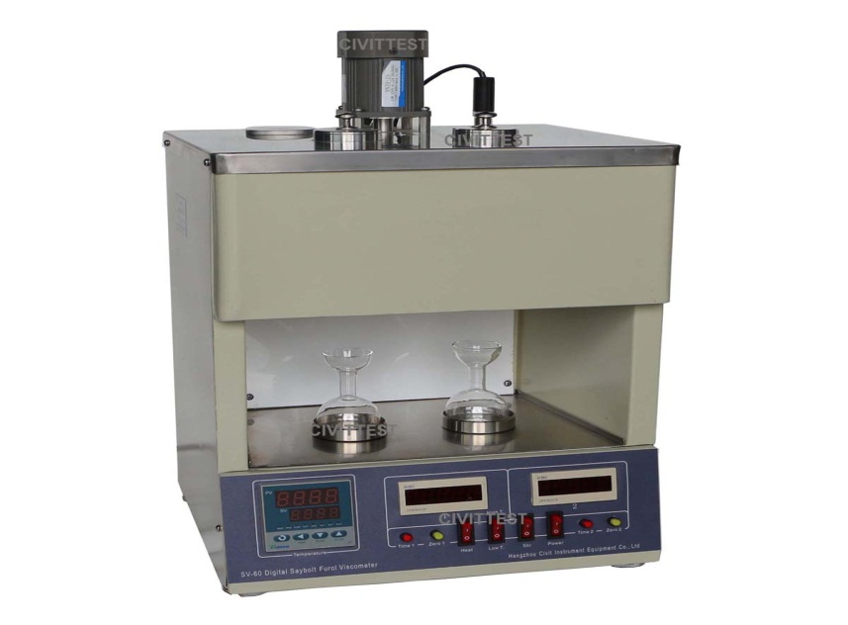
Figure1: Saybolt Viscometer test

- Receiving Flasks
- Thermometers
- Timer.

Preparation of Apparatus:

1. Clean viscometer and receiving flask thoroughly with appropriate solvent.
2. Place the receiving flask beneath the viscometer so that the graduation mark on the flask is from (100-130) mm. below the bottom of the viscometer tube.
3. Fill the bath to at least 6 mm. above the over flow rim of the viscometer, the bath media used is water or oil for test temperature less than 98 PᵒPC and oil for higher test temperature.

Procedures :
1. Establish and control bath temperature.
2. Insert a cork stopper at the bottom of the viscometer.
3. Preheat the sample to not more than 1.7PᵒPC above test temperature, and 28 PᵒPC of its flash point.
4. Stir the sample and strain it through sieve No. 100 directly into the viscometer.
5. Stir the sample in the viscometer with the thermometer, use a circular motion at (30to 50) rpm in a horizontal plane. Remove thermometer when the temperature remains constant within 0.03PᵒPC of the test temperature during one minute of continuous stirring.
6. Place the tip of the withdrawal tube in the gallery at a point and apply suction to remove oil until its level in the gallery is below the over flow rim.
7. Place the receiving flask in its proper position.
8. Snap the cork and start the timer.
9. Stop the timer the instant the bottom of the oil meniscus reaches graduation mark.
10.Record the efflux timer in seconds to the nearest 0.1 sec. This will be the viscosity.

Result :
1. Report the time in seconds to the nearest 0.1 sec. and the test temperature in PᵒPC.
2. To draw the relationship between viscosity and temperature, arrange a table contains (temperature and efflux time) as follows:-

Test number | Temperature $℃$ | Efflux time (viscosity) sec.

3. Draw the curve, it must be as shown :
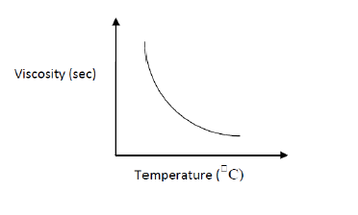
4. The viscosity, in centistokes can be calculated using this equation:
η = 0.22θ – 180 / θ when, 30 < θ < 500
or
η = 0.216θ when, θ > 500
Where: η = viscosity in centistokes
θ = viscosity in SUS

Discussion:
1. Importance of Saybolt viscosity test.
2. What is the effect of temperature on viscosity?
3. What is used in the bath media of viscosity test? Why?
4. Set another method to determine the viscosity.
5. What is the theoretical meaning of viscosity of material ?
6. What is the relation between penetration and viscosity? Explain that .

Reference :
ASTM D88-99 : "Standard test method for Saybolt viscosity".
Dade, W. B., Nowell, A. R. M., & Jumars, P. A. (1992). Predicting erosion resistance of muds. Marine geology, 105(1-4), 285-297.‏
Kett, I. (2012). Asphalt materials and mix design manual. William Andrew.‏

