محاضرة البايولوجي النظري -6

What is a chromosome definition?

A structure found inside the nucleus of a cell. A chromosome is made up of proteins and DNA organized into genes. Each cell normally contains 23 pairs of chromosomes.
A structure found inside the nucleus of a cell. A chromosome is made up of proteins and DNA organized into genes. Each cell normally contains 23 pairs of chromosomes.
The structure and location of chromosomes are among the chief differences between viruses, prokaryotes, and eukaryotes. The nonliving viruses have chromosomes consisting of either DNA (deoxyribonucleic acid) or RNA (ribonucleic acid); this material is very tightly packed into the viral head. Among organisms with prokaryotic cells (i.e., bacteria and blue-green algae), chromosomes consist entirely of DNA. The single chromosome of a prokaryotic cell is not enclosed within a nuclear membrane. Among eukaryotes, the chromosomes are contained in a membrane-bound cell nucleus. The chromosomes of a eukaryotic cell consist primarily of DNA attached to a protein core. They also contain RNA. The remainder of this article pertains to eukaryotic chromosomes.

Types of Chromosomes
Chromosomes are divided into two parts (p and q arms) with a constriction point called a centromere in the middle.
The centromere can be located in different positions and this forms the basis for the four different classes of chromosome:
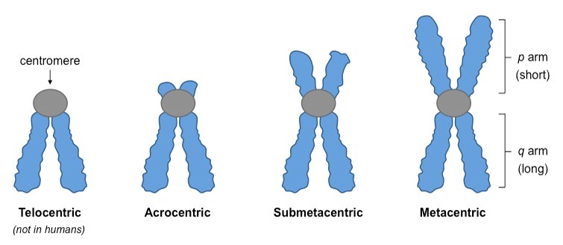

Metacentric – centromere is in middle, meaning p and q arms are of comparable length (e.g. chromosomes 1, 3, 16, 19, 20)
Submetacentric – centromere off-centre, leading to shorter p arm relative to q arm (e.g. chromosomes 2, 4 – 12, 17, 18, X)
Acrocentric – centromere severely off-set from centre, leading to much shorter p arm (e.g. chromosomes 13 – 15, 21, 22, Y)
Telocentric – centromere found at end of chromosome, meaning no p arm exists (chromosome not found in humans).

Can changes in the structure of chromosomes affect health and development?
Changes that affect the structure of chromosomes can cause problems with growth, development, and function of the body's systems. These changes can affect many genes along the chromosome and disrupt the proteins made from those genes.
Structural changes can occur during the formation of egg or sperm cells, in early fetal development, or in any cell after birth. Pieces of DNA can be rearranged within one chromosome or transferred between two or more chromosomes. The effects of structural changes depend on their size and location, whether gene function is interrupted, and whether any genetic material is gained or lost. Some changes cause health problems, while others may have no effect on a person's health.
Changes in chromosome structure include the following:
Translocations
A translocation occurs when a piece of one chromosome breaks off and attaches to another chromosome. This type of rearrangement is described as balanced if no genetic material is gained or lost in the cell. If there is a gain or loss of genetic material, the translocation is described as unbalanced.

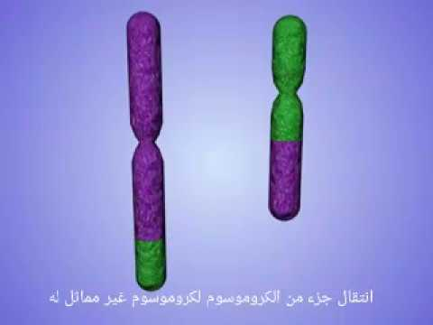

Deletions
Deletions occur when a chromosome breaks and some genetic material is lost. Deletions can be large or small, and can occur anywhere along a chromosome.
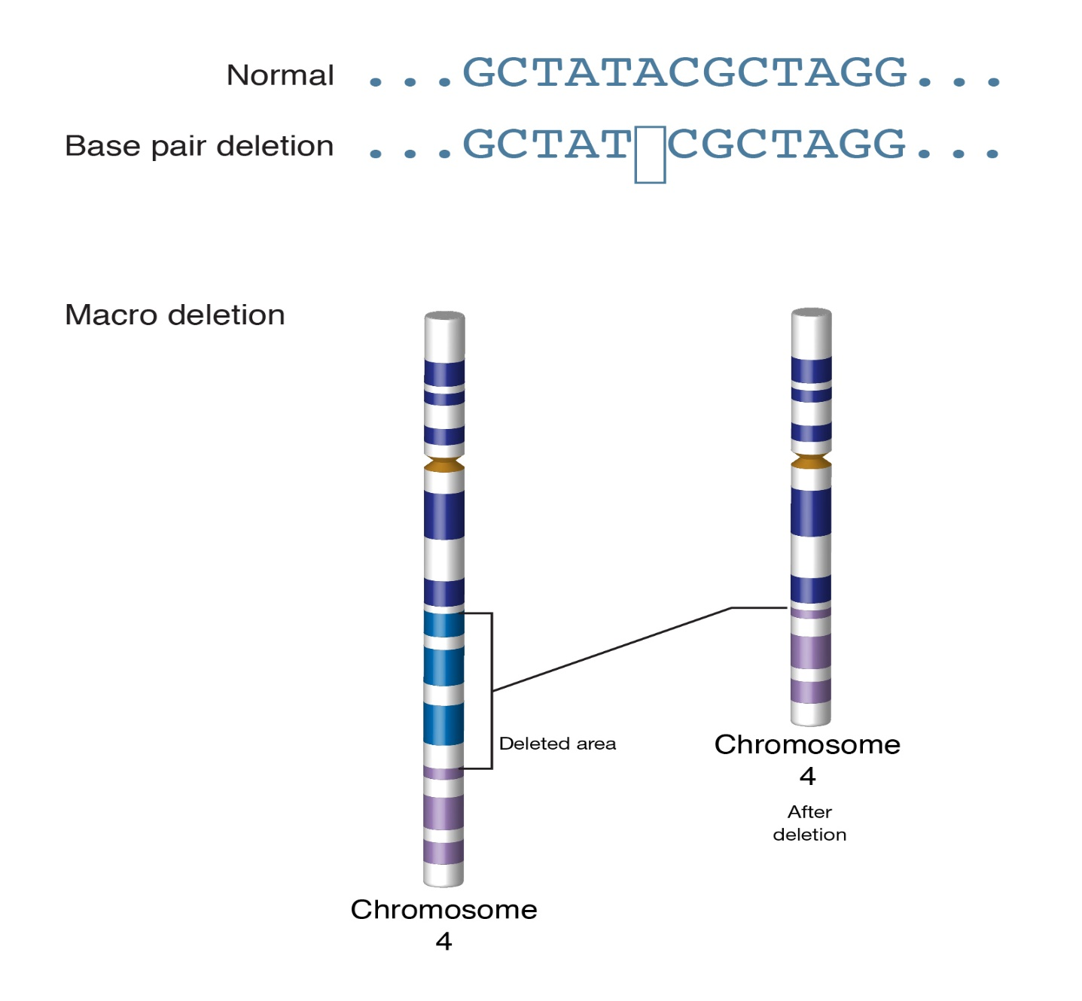

Duplications
Duplications occur when part of a chromosome is abnormally copied (duplicated). This type of chromosomal change results in extra copies of genetic material from the duplicated segment.

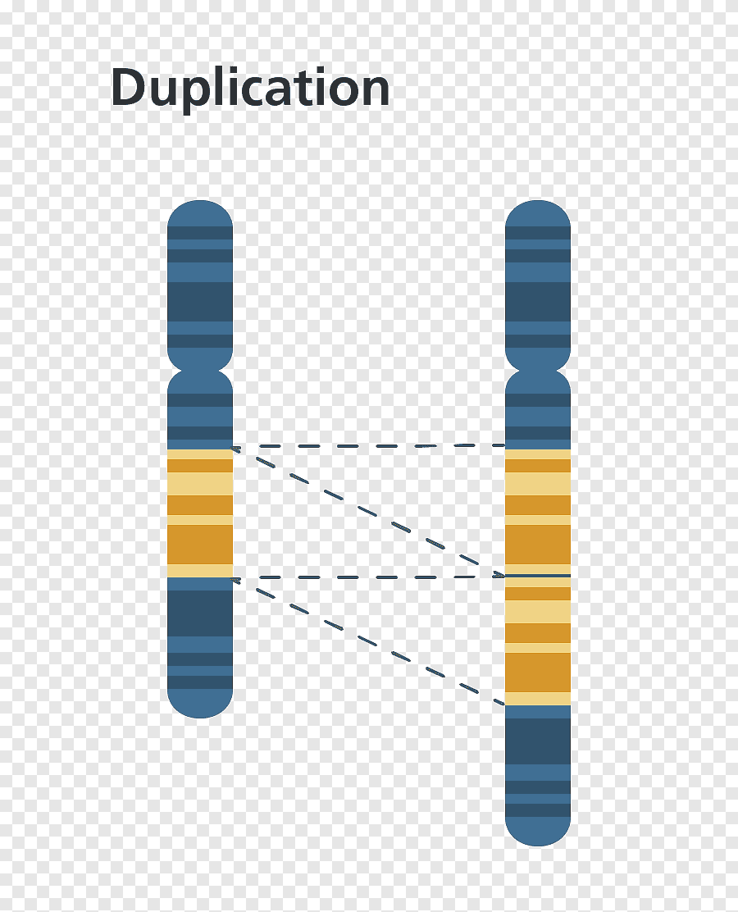

Inversions
An inversion occurs when a chromosome breaks in two places; the resulting piece of DNA is reversed and re-inserted into the chromosome. Genetic material may or may not be lost as a result of the chromosome breaks. An inversion that includes the chromosome's constriction point (centromere) is called a pericentric inversion. An inversion that occurs in the long (q) arm or short (p) arm and does not involve the centromere is called a paracentric inversion.

