محاضرة البايولوجي النظري -10

Difference between Gram-Positive and Gram-Negative Bacteria
Following are the important differences between gram-positive and gram-negative bacteria:
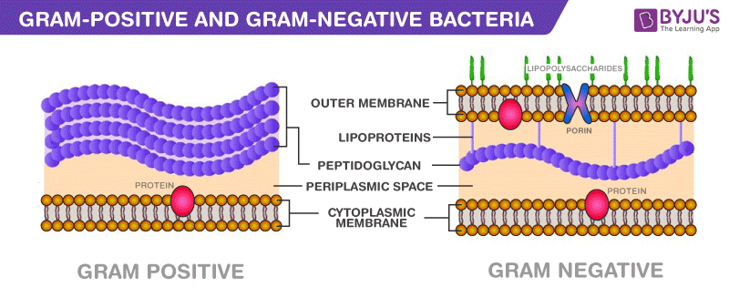
Gram-Positive bacteria | Gram-Negative bacteria
Cell Wall
A single-layered, smooth cell wall | A double-layered, wavy cell-wall
Cell Wall thickness
The thickness of the cell wall is 20 to 80 nanometres | The thickness of the cell wall is 8 to 10 nanometres
Peptidoglycan Layer
It is a thick layer/ also can be multilayered | It is a thin layer/ often single-layered.
Teichoic acids
Presence of teichoic acids | Absence of teichoic acids
Outer membrane
The outer membrane is absent | The outer membrane is present (mostly)
Mesosome
It is more prominent. | It is less prominent.
Lipid content
Very low | 20 to 30%
Lipopolysaccharide
Absent | Present
Toxin Produced
Exotoxins | Endotoxins or Exotoxins
Resistance to Antibiotic
More susceptible | More resistant
Examples
Staphylococcus, Streptococcus, etc. | Escherichia, Salmonella, etc.
Gram Staining
These bacteria retain the crystal violet colour even after they are washed with acetone or alcohol and appear as purple-coloured when examined under the microscope after gram staining. | These bacteria do not retain the stain colour even after they are washed with acetone or alcohol and appear as pink-coloured when examined under the microscope after gram staining.

Anatomy of BACTERIAL CELL
- Capsule: slimy layer, consisting of polysaccharide and water surrounding many cells. Also called slime coat, extracellular layer, etc .

- Cell Wall: rigid layer surrounding the bacterial cell. Made of peptidoglyan in bacteria, other materials in archaea. Porous to movement of small molecules.

- Cell Membrane: flexible, semi-permeable barrier with lipid center that controls diffusion in and out of cell.

- Cytoplasm: the fluid-filled space inside the cell. Contains hundreds of different enzymes, along with ribosomes, DNA, RNA, and a "pool" of millions of small molecules and ions.

- Ribosomes: particles made of protein and RNA, sites of protein assembly. Ribosomes may occupy 25% of the volume of a typical bacterial cell.
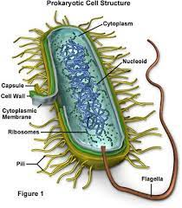

Gram stain: staining technique for the preliminary identification of bacteria, in which a violet dye is applied, followed by a decolorizing agent and then a red dye. The cell walls of certain bacteria (denoted Gram-positive ) retain the first dye and appear violet, while those that lose it (denoted Gram-negative ) appear red.

The procedure/steps of Gram Stain
- Prepare and fix the specimen to the microscope slide before staining.
- Cover the smear with crystal violet, the primary stain, for 20 seconds.
- Gently rinse off the stain with water.
- Cover the smear with Gram’s iodine, the mordant, for 1 minute.
- Pour off the excess Gram’s iodine.
- Run the acid-alcohol decolorizer over the smear until the solution appears clear.
- Gently rinse with water.
- Cover the smear with safranin, the secondary or counterstain, for 20 seconds.
- Gently rinse the stain with water.
- Blot dry with bibulous paper.

Bacterial cellular morphologies

1-Coccus[edit]
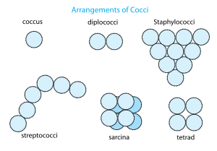
Arrangement of cocci bacteria

:Staphylococcus bacteria
A coccus (plural cocci, from the Latin coccinus (scarlet) and derived from the Greek kokkos (berry)) is any microorganism (usually bacteria)^{[1]} whose overall shape is spherical or nearly spherical.^{[2]} Describing a bacterium as a coccus, or sphere, distinguishes it from bacillus, or rod. This is the first of many taxonomic traits for identifying and classifying a bacterium according to binomial nomenclature.
Important human diseases caused by coccoid bacteria include staphylococcal infections, some types of food poisoning, some urinary tract infections, toxic shock syndrome, gonorrhea, as well as some forms of meningitis, throat infections, pneumonias, and sinusitis.^{[3]}

Arrangements
Coccoid bacteria often occur in characteristic arrangements and these forms have specific names as well;^{[4]} listed here are the basic forms as well as representative bacterial genera:
- pairs or diplococci (e.g. Neisseria spp.)
- groups of four or eight known respectively as tetrads and sarcina (e.g. Micrococcus spp.)
- chains (e.g. Streptococcus spp.)
- clusters (e.g. Staphylococcus spp.)

2-Bacillus[edit]
A bacillus (plural bacilli) is a rod-shaped bacterium. Although Bacillus, capitalized and italicized, specifically refers to the genus, the word bacillus (plural bacilli) may also be used to describe any rod-shaped bacterium, and in this sense, bacilli are found in many different taxonomic groups of bacteria. There is no connection between the shape of a bacterium and its colors in the Gram staining.

Arrangements[edit]
Bacilli usually divide in the same plane and are solitary, but can combine to form diplobacilli, streptobacilli, and palisades.^{[5]}
- Diplobacilli: Two bacilli arranged side by side with each other.
- Streptobacilli: Bacilli arranged in chains.^{[6][7]}

3-Spiral
Spiral bacteria are another major bacterial cell morphology. Spiral bacteria can be sub-classified as spirilla, spirochetes, or vibrios based on the number of twists per cell, cell thickness, cell flexibility, and motility.
Bacteria are known to evolve specific traits to survive in their ideal environment. Bacteria-caused illnesses hinge on the bacteria’s physiology and their ability to interact with their environment, including the ability to shapeshift. Researchers discovered a protein that allows the bacterium Vibrio cholerae to morph into a corkscrew shape that likely helps it twist into — and then escape — the protective mucus that lines the inside of the gut.^{[1}

