Cardiovascular system
The cardiovascular or circulatory system supplies the body with blood. It consists of the heart, arteries, veins, and capillaries.
- Heart = 4 chambers - R & L atria, R & L ventricles
Blood from circulation to R atrium to R ventricle to pulmonary artery to lungs for gas exchange (CO₂ & O₂) to L atrium to L ventricle to aorta to systemic circulation
- Heart muscle
myocardium & surrounds the atria & ventricles.
Pericardium = fibrous covering around the heart that protects it from injury & infection.
Endocardium = 3-layered membrane that lines the inner part of the heart chambers
- Valves = 4 - two atrioventricular (tricuspid & mitral) & 2 semilunar (pulmonic & aortic) - control blood. flow between atria & ventricles & pulmonary artery & the aorta.
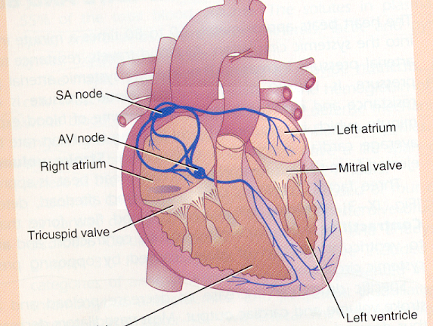
Blood flow & Heart Rate (HR)
- Ave. HR = 60 - 80 beats/min. (adult).
- Ave. BP = 120/80 mm/Hg - resistance to blood.
Diseases and conditions that affect the heart include:
- angina: a type of chest pain that occurs due to decreased blood flow into the heart
- arrhythmia: or an irregular heartbeat or heart rhythm
- congenital heart disease: in which a problem with heart function or structure is present from birth
- coronary artery disease: which affects the arteries that feed the heart muscle
- heart attack: sudden blockage to the heart’s blood flow and oxygen supply
- heart failure: wherein the heart cannot contract or relax normally.
Medication Groups
- Beta Blockers: action on the sinus node, if conduction is blocked then HR is decreased leading to a fall in BP, caution in asthma and COPD as affects all smooth muscle and used for relief from angina, HTand arrhythmia. Such as Propanolol, labetolol, metoprolol, (betaloc), sotalol, celiprolol, atenolol.
- Ca Chanel Blockers: Used in coronary artery spasm.(Nifedipine/Felodipine acts on blood vessels and Verapamil/Diltiazem acts on the heart muscle.
- Nitrates: action has direct effect on veins, dilates veins so less blood is returning to the heart, therefore, the heart does not have to pump so hard and fast (systole) and resting phase is longer hence allowing more blood and O₂ to the myocardium (diastole), used for relief from angina, HT & cardiac failure. such as Isosorbide mono-nitrate, (duride) isosorbide di-nitrate, (coronex).
- ACE Inhibitors: (ACE = Angiotensin Converting Enzyme), action affects both the heart and kidneys such as Captopril, cilazopril, enalapril, quinapril.
- Diuretics: action is directly on the kidney (Bendrofluazide ,Frusemide, Bumetanide ,Aldactone, Amiloride).
- Digoxin: action is to inhibit Na/K exchange across the cell membrane.

