Organs of the body | Their Locations and Internal Functions
There are approximately 74 major organs in the human body. They combine together to form the organ systems which carry out our body’s vital functions.
Below, we will see important organs that are present in different locations of human anatomy.

List of Organs of the body
Organs are the structures formed by a group of tissues. The human body organs of different types and can be grouped into sections like
  - Of Digestion: Esophagus, Stomach, liver, pancreas, small intestine, large intestine, rectum, and anus.
  - Of Respiration: Lungs, nose, trachea, bronchi.
  - Of Excretion: Kidneys, urinary bladder, urethra
  - Circulation: Heart, blood vessels, spleen.
  - The Nervous system: Brain and spinal cord.
  - Reproduction: Testis & penis in the male. Uterus, ovaries & mammary glands in the female.
  - Endocrine system: Pituitary gland, adrenal, thyroid, pancreas, parathyroid, prostate glands.
  - Sense organs: Skin, tongue, nose, eyes, ears.
  - Of the Immune system: Spleen, thymus, bone marrow, lymph nodes, lymph vessels.

Organs in the body and their function in detail

Organs of digestion
These organs start from the mouth and end with the rectum. They are of different types like
- Mouth
- Pharynx.
- Esophagus
- Stomach
- Small intestine
- Large intestine
- Rectum
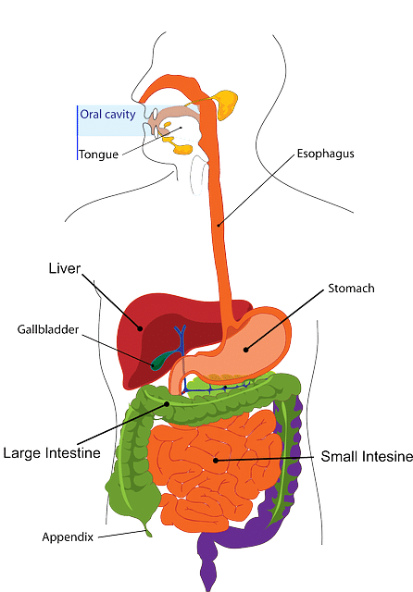
Mouth and Pharynx
The mouth is the entry point into the digestive system of the human body. From there, food moves through the pharynx into esophagus.
The esophagus
This is the starting organs in the digestive system. It carries food from the mouth to the stomach.
Stomach
It is one of the largest internal organs. It is a sack-like structure located in the belly portion of the body. Its capacity is up to 2.5 liters.
It has folding called rugae by which it expands to accommodate more food. Food consumed stays in the stomach for about an hour. The stomach wall secretes HCl, which destroys any microbes in the food. Further, it readily absorbs water and alcohol and digests some portions of carbohydrates.
Small intestine
This is a long tube-like structure with a length of about 5 to 6 meters. It is a continuation of the stomach up to the Cecum. It has 3 major parts like
- Duodenum
- Ileum
- Jejunum
The food from the stomach enters the small intestine and stays for 8 hours. Here the food is digested, and then the nutrients are absorbed into the bloodstream.
Large intestine
This is an extension of the small intestine but has a greater diameter. It is divided into
- ascending colon,
- transverse colon,
- descending colon,
- sigmoid colon and
- rectum.
This digestive system helps in the absorption of water from the undigested food; stores bowel before being excreted as feces.
Further, it hosts many friendly bacteria that synthesize Vitamin-K and also helps in the absorption of vitamin-B12.

Accessory organs of digestion
These are the vital organs that aid in digestion. These consists of
- Salivary glands
- Liver
- Pancreas.
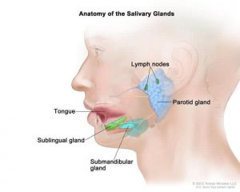Image Dana-Farber cancer institute
Salivary glands
There are three pairs of salivary glands in the facial region. They secrete saliva into the mouth to keep it moist and help in the digestion of carbohydrates.
Liver
It is considered the biggest organ in the human body. It weighs around 2 to 3 kg making it the heaviest internal organ in a healthy adult.
It is located on the right side of the body above the stomach, as seen in the image above.
It is an essential organ of metabolism and one of the principal organs in the human body that detoxifies substances.
It helps to convert any toxic substances or drugs into water-soluble inert materials. These are then readily excreted by the kidneys.
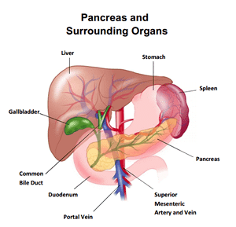
It is the organ where glucose is stored as glycogen and fat are converted to high-density and low-density lipoproteins.
It is also the place where bile is formed and released into the intestine for excretion. It is the most robust and active organ in the body. Damage to any portion of the liver is regenerated and repaired for efficient function.
Gall-bladder
It is a small organ below the liver. Here the bile juice from the liver is concentrated before being released into the gut. See the image above for the location.
Pancreas
This organ located near the stomach acts as both an exocrine gland and also the endocrine gland.
The exocrine gland secretes digestive enzymes like amylase, trypsin, lipase, which digest carbohydrates, proteins, and fats, respectively. See the pancreatic enzymes for more details.
While the endocrine part secretes hormones like insulin, somatotropin which regulate glucose levels in the blood.

Organs of Circulation
These include the heart and blood vessels like the arteries, veins, and capillaries.
Heart
This is the primary organ of the blood circulatory system. It is one of the organs on the left side of the body.
The heart’s function is to pump blood to reach deeper most tissues of the body.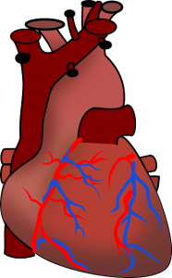
It is the organ that functions non-stop from the time of its formation in the womb until an individual’s death.
It has veins flowing in blood from the back and arteries going out of the heart. In an adult, it beats at an average of 72 beats per minute. It is made of cardiac muscles, which are part of the muscular system.
Arteries, Veins & Capillaries
These are duct-like organs that are connected to the heart. Arteries carry blood from the heart to all the tissues and cells of the body.
Veins bring impure blood from all the tissues and cells back to the heart. Capillaries are the finest ducts which emerge from arteries and converge again into veins.
They reach deeper into most cells and provide nutrition and collect waste for expulsion by blood. There are few structural and functional differences between arteries and veins.

Organs of respiration
The list includes
- Nose
- Larynx
- Trachea
- Bronchi
- Lungs
Lungs
These are the principal organs in the respiratory system. They help in taking oxygen-rich air from the atmosphere into the body and give out carbon dioxide.
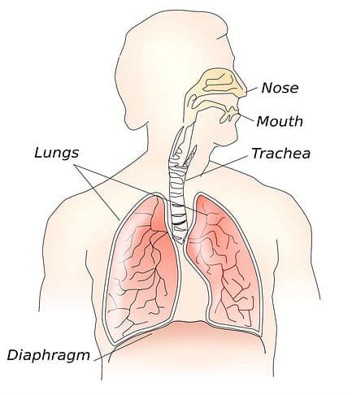
The oxygen from the air in the lungs is carried by blood when it circulates through the alveoli. These lungs are balloon-like and can expand and relax. The average capacity is 4 liters of air.

Organs of nervous system
Brain
This is the master organ of the body. All the organ systems of the human body are under its control. The skull, which is a bone frame in the head, houses the brain.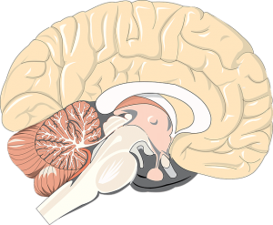
It is made up of nerve cells and neuroglia.
It consists of parts like the cortex, cerebral hemisphere, cerebellum, medulla oblongata, pons. It extends into the spinal cord.
For more details, refer to the article Parts of the brain.
Its essential functions include judgment, memory, reasoning, sleep, temperature control, body movements, reflex actions, etc. It exerts its action through neurotransmitters.
Spinal cord
This is the cord located in the vertebral column. It begins from the brain and extends to hip bones like the sacrum. It has many nerves passing through the entire body. Along with the brain is a part of the nervous system.

Organs of urinary system
Kidneys
These are the main organs involved in the excretion process. They are involved in removing waste from the blood. There is a single pair of kidneys present towards the dorsal side of the body. They are bean-shaped and brownish in color. Each kidney is located on either side of the vertebral column.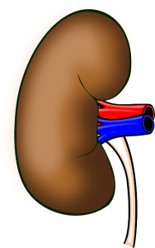
They filter waste products from the blood for expulsion. A nephron is the basic unit of excretion in the kidney. Each kidney has millions of nephrons that combine to perform such large demands of filtration.
Ureters
These are the long ducts that connect the kidneys to the urinary bladder. They carry the formed urine from nephrons to the bladder for expulsion.
Urinary bladder
This is a storage vesicle which stores urine brought from kidneys by the ureters until there is voluntary urination.
Urethra
This is a tube-like extension which originates from the urinary bladder and opens to the outside.

Sense Organs
These constitute five major organs which are parts of different organ systems. These include
- Skin
- eyes
- ears
- nose
- tongue
Skin
This is the largest organ of the body in terms of the area. It belongs to the integumentary system.
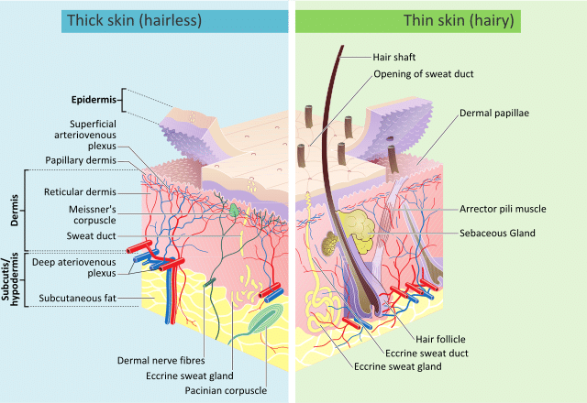By: Madhero88 & M.Komorniczak -commons.wikimedia.org/
It accounts for a few square meters in area. It covers the whole body, gives shape, and protects the inner tissues from germs.
It also acts as an organ of the sense of touch. The skin has sweat ducts, oil glands, and hair. In times of excess heat, the body expels sweat through the skin to reduce body temperature.
Along with sweat, sodium, chloride, and other waste are excreted from the body. This skin also acts as an organ of excretion. Glands in the skin secrete an oily substance to prevent water loss and keep the surface smooth.
Eyes
The eyes are one of the 5 sense organs. They are the most vital organs which help in daily life activities.
They are a pair located in eye sockets in the skull on the front side of the head.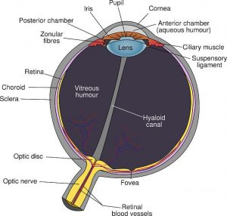
They are responsible for vision. Eyes are connected to the brain through optic nerves, which help insight.
They work together with ears for better balance, with nose and tongue to enhance the appetite on the sight of food.
Ears
These are meant for hearing and body balance. They are a pair, each located on one side of the head.
The ears perform specific functions like the sense of hearing and the maintenance of body balance.
This way, they help in communication and safety.
Nose
This is an organ of respiration but also has the function of the sense of smell. It has olfactory nerve endings in the nasal layers, which predict the scent.
Tongue
This the organ located in the mouth. It has sensory buds which act as chemoreceptors. The specific functions of the tongue are to recognize the taste, making a speech, including chewing the food.

Endocrine glands
Pituitary gland
This gland is located in the brain but releases important organs that regulate body physiology.
Thyroid gland
This is an endocrine gland located near the neck region. It secretes thyroid hormones, which regulate metabolism and also body temperature.
Parathyroid gland
This is also the endocrine gland located along with the thyroid gland. They secrete parathormone, which regulates calcium levels in the blood.
Adrenal glands
This endocrine gland has two portions as the inner medulla, which secretes epinephrine, while the outer cortex secretes mineral and glucocorticoid hormones.
Epinephrine is the hormone of fight or flight (emotion-related), while corticoids regulate body metabolism.
Pineal gland
This is a small reddish-brown colored gland present in the brain. It secretes the hormone melatonin, which regulates the circadian rhythm.
Refer for more details on glands in the body

Organs of Lymphatic system
This includes organs like
Spleen
This organ is a part of the lymphatic system. It is located in the belly region near the intestines and stomach. It is involved in the infiltration of blood, the destruction of old and worn-out red blood cells. This also serves as a reservoir of blood and even recovers iron from damaged RBC for reuse.
Thymus gland
An essential organ of the immune system, located near the sternum. This organ helps in the development of immune cells. It decreases in size as age progresses.
Lymph nodes
These are oval-shaped organs lying along the length of the lymph vessels. They help infiltration of lymph, destruction of cell debris, and proliferation of T and B-lymphocytes.
Lymph vessels
These are the vessels that are found running beside the blood vessels. They carry the lymph away from tissues to mix into venous blood.

