8-Weathering, Erosion and Soil Formation
Introduction:-
Rock decay with little or no transport of the products is termed weathering; and when the rock or its products is simultaneously removed, this is termed erosion. Soil erosion is caused by the action of water and wind. Surface runoff and wind together carry away loosened soil. Soil is produced by weathering, a term including variety of chemical, physical, and biological processes acting to break down rocks. It may be formed directly from bedrock, or from further breakdown of transported sediment such as glacial till. The relative importance of the different kinds of weathering processes is largely determined by climate. Climate, topography the composition of the material from which the soil is
formed, the activity of organisms, the time govern a soil’s final composition.
External processes:- are responsible for transforming solid rocks into sediment and are
therefore a basic part of the rock cycle.
*Three processes of weathering and erosion at, and near, the surface transform solid rock into unconsolidated rock waste. These are as follows:
a- The physical or mechanical disintegration of a rock mass at the surface as water, wind, ice and the rock fragments carried by them .
b- Chemical reactions between the original minerals o f the rock.
c- Biological activity, which produces organic acids, thus adding to the chemical reactions.
Weathering :- The disintegration and decomposition of rock at or near the surface of the earth.
Erosion:- The incorporation between (disintegration& decomposition of rock) and (transportation) of material by mobile agent, usually water, wind or ice.
Types of Weathering :-
1- Physical (Mechanical) Weathering
Mechanical weathering / is accomplished by physical forces that break rock into smaller and smaller pieces without changing the rock's minerals composition.

Kinds of mechanical weathering:-
a- Freezing of water within a crack produces an expanded wedge of ice which
forces the walls of the crack apart.
b- The same mechanical effect may be produced locally in the rock by chemical
reactions between certain minerals and water that has penetrated along cracks.
c- Other processes involving the action of water in its various forms include
erosion by ice, wave action at coasts, river erosion, and slopes being made
unstable by the presence of water in the ground.
d- Expansion and contraction of the outer skin of a rock mass as it was heated
by the sun and cooled at night were formerly thought to be an important agent of
weathering, but careful modern studies show that this process (called
exfoliation) requires water to be present for it to work.
e- Crystal growth and salts.
f-Granular disintegration.
g- Near-surface rock removal.
2- Chemical Weathering
Chemical weathering is changing the chemical structure of minerals by removing and/or adding elements.
Types of chemical weathering:
1- Dissolution: Water is one of the most effective solvents. Some rock types can be completely dissolved and leached away by water. Rock salt (NaCl) is the best known example.
2-Reduction: takes place in environments deficient in oxygen, and the products
of such a reaction contain relatively little oxygen. For example, in oxidizing
conditions organic matter is converted to carbon dioxide (CO2), but in reducing
conditions methane (CH4) is often formed.
3- Oxidation: In this process, atmospheric oxygen combines with a mineral to
produce an oxide. The process is important in the weathering of minerals with
high iron content, such as olivine, pyroxene and amphiboles. The iron in silicate
mineral units oxygen to form hematite ( Fe2O3) or limonite ( Fe2O3 .3H2O) rock
constituent, and in two typical reactions produces new iron-bearing minerals.
4- Carbonation: It is a reaction involving carbonic acid and limestone. Carbonic acid is formed when carbon dioxide from the atmosphere dissolves in water. It can then react with limestone (calcite) to produce soluble calcium or sodium bicarbonate.
5- Hydration: It is a reaction in which water combines with a rock constituent
producing a mineral that has hydroxyl groups (OH) in its structure, the hydroxyl
group coming from the water. An example is the transformation of anhydrite to
gypsum.
6- Solutions: The primary erosional work carried out by surface and
groundwater is that of dissolving rocks. Since soluble rocks (rock salt, gypsum
and limestone),especially limestone, underlie millions of square kilometers of
the earth s surface, it is here that groundwater carries on when groundwater comes in
contact with limestone , the carbonic acid reacts with calcite in the rocks to form calcium bicarbonate, a solouble material that is then carried away in solution.
7- Hydrolysis: The chemical union of water and a mineral is known as hydrolysis. In hydrolysis, ions derived from one mineral react with the H or OH ions of the water to produce a different mineral.
3-Biological Weathering
Weathering is also accomplished by the activities of organisms, including plants, burrowing animals and humans. Plant root widens cracks and contributes to the rock breakdown. Burrowing animals further breakdown rock by moving fresh material to the surface, where physical and chemical processes can more effectively attack it.
Factors influences the type and rate of weathering:
1- The amount of mechanical weathering that has taken place.
2- The mineral composition of the rock.
3- The degree of jointing (fracturing).
4- Climate.
5- Temperature and moisture.

The depth of weathering depends very much on :
1- local climatic effects (such as ground temperature).
2- soil/rock type .
3- time.

Soil and Soil Formation:-
Geologists and engineers give different meanings to the word "soil".
Geologists use the term to refer to any rock waste, produced by the disintegration of rocks at the surf ace by weathering processes, which has formed in situ, include all unconsolidated material overlying bedrock. These un transported surface deposits are called resident or residual deposits.
In contrast, engineers use the term "soil" more widely and more loosely, to describe any superficial or surficial deposit which can be excavated without blasting. This definition covers transported sediments as well as residual deposits.
Thus, engineers would regard "soil" as including water-transported sediments (alluvium), wind transported material (dunes and loess), sediment transported by glaciers or their melt waters (till or glacial drift) and material moved downhill by gravity (colluvium). Some rocks (such as London Clay) may even be thought of as "soil" by the engineer, since these can be easily excavated.

(Types of Soils)
1- Residual Soils
These are un transported soils produced by the disintegration of rocks at the
surface by weathering processes, which has formed in situ.
Their Thickness depends upon climate, original rock type and time.
The main characteristics of this soil are:
1- The mineralogical composition is closely related to the original bed rock beneath soil.
2- The soil grains are irregular, sharp and lack roundness.
3- The soil contains fragments of the original rock.
4- The soil thickness depends upon the depth of weathering, climatic conditions, nature of rocks, topography and time.
soil profile:-
The presence of complete soil profile reflecting the gradual change from original rock at the bottom to top soil at the surface
Since soil forming processes operate from the surface downward,*
* variation in composition, texture, structure and color gradually evolve at varying
depths .
*Four basic horizons are identified and from top to bottom are designated
as (O, A, B and C).
O-horizon: It consists largely of organic material. A-horizon: It consists mainly of mineral matter.
B-horizon: Immediately below the A-horizon is the B-horizon or subsoil ,much of the fine clay material removed from the A-horizon by water .
C-horizon: A layer characterized by partially altered parent material It may be considered a transitional zone.

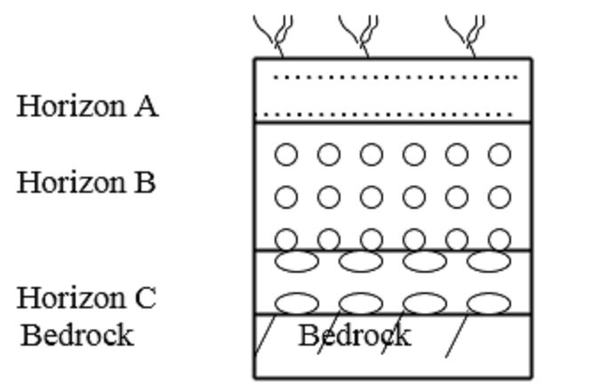
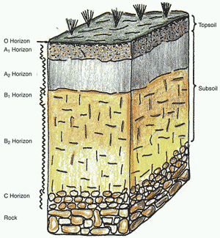

Classification of residual soils:-
Most modern soils develop profiles related to the climatic and vegetational zones in which they occur, and for this reason they are referred to as zonal soils.
1- Laterites: Red soils rich in iron oxides and alumina abundant in the hot wet climates of the tropics (i.e. high temperatures and heavy rainfall).
2- Brown Soils: A mixture of clay and sand rich in iron oxides and organic matter.
3- Black Soils: Dark colored soils rich in organic matter.
2-Transported soils:-
Those developed on unconsolidated sediment that are formed of rock debris which has been carried by some natural agent from where it was formed by weathering and erosion to where it now occurs. These soils are characterized by the absence of the C-horizon, also A and B-horizons are not well pronounced particularly when the soil is recent.

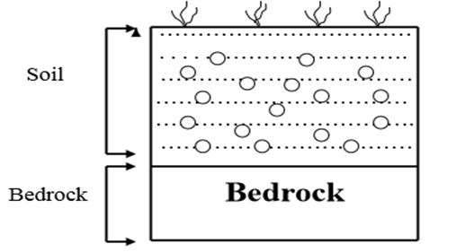

Classification of Transported Soils:-
1- Aeolian (Windborne) Deposits (Soils): A strong wind blowing across rock debris or soil can lift and carry fine material as dust, and can move the larger sand grains by rolling them and making them bounce across the surface.
a- Loess: The finer, yellow-colored, silt-sized fraction (0.002-0.006 mm) is carried in suspension by the wind, and may travel great distances before it is eventually deposited as loess. They are composed mainly of quartz, feldspar, calcite and mica with a
smaller fraction of other stable minerals such as iron oxides. Clay minerals are virtually absent.
b- Sand dunes: The coarser rounded material that remains forms sand dunes, composed mainly quartz with little feldspar. They are found in desert regions, although the process also operates in some coastal areas.
2- Glacial (Ice borne) Deposits (Soils): Erosion by ice, and deposition of superficial deposits from it, are processes limited geographically at the present day to arctic regions and to very high mountains.
3- Aqueous Deposits (Soils): The soils that are deposited by running or slack water which are considered the most important soils in Iraq.
a- Continental Deposits : They include fresh water deposits :
I- Alluvial (Riverborne) Deposits (Soils): They include river, flood plain and deltaic soils . Lateral erosion by a river into its banks eventually produces a valley which is much wider than its course. Erosion at one point is matched by deposition at another and a wide valley is eventually filled with alluvial deposits . These include cross - bedded and evenly bedded sands, silts and gravels, plus spreads of fine silt and clay across the flat flood plain at the sides of a river.
II- Lacustrine Soils: They composed mainly of silts deposited in lakes and
reservoirs .
b- Marine Deposits: They include all sediments of the marine and transitional environments.
Mineral Composition of Soil :-
Of the hundred or so elements known, only eight are abundant at the earth’s surface. These, in decreasing order of abundance, are oxygen (O), silicon (Si), aluminum (Al), iron (Fe), calcium (Ca), sodium (Na), potassium (K) and magnesium (Mg). The common rock-forming minerals are formed mainly of combinations of these important elements, and most of them are silicates.

Clay Minerals and their Groups:-
clay minerals are complex hydrous aluminum silicates
composed of two basic units:
( l) silica tetrahedron and; (2) alumina octahedron unit (gibbsite Al(OH)3).
Each tetrahedron unit consists of four oxygen atoms surrounding a silicon atom.
The combination of tetrahedral silica units gives a silica sheet. The octahedral units consist of six hydroxyls surrounding an aluminum atom, and the combination of the octahedral aluminum hydroxyl units gives an octahedral sheet. This is also called a gibbsite sheet.
a- Kaolinite Group: Al2Si2O5(OH)4
Of the three important clay minerals, kaolinite consists of repeating layers of elemental silica-gibbsite sheets in a 1: 1 lattice since one silica layer is coupled with one gibbsite layer (G) as shown in Figure 5.3a. Two units are held together by attraction (van der Waals’ forces). The layers are held together by hydrogen bonding. It is less soluble in water. The weak forms contain a layer of water between silica-gibbsite sheets. Thus, from engineering point of view, it is considered to have the lowest swelling, tenacity and permeability
b- Illite Group: KAl2(AlSi3)O10(OH)2
Illite consists of a gibbsite sheet bonded to two silica sheets- one at the top and another at the bottom (Fig. 5.3b). Illite, like the micas, is termed a 2:1 sheet silicate since one sandwich unit consists of two silica layers with one gibbsite layer between. The units are joined or bonded by potassium ions (K+ ions). It is sometimes called clay mica. The negative charge to balance the potassium ions comes from the substitution of aluminum for some silicon in the tetrahedral sheets. Substitution of one element for another with no change in the crystalline form is known as isomorphous substitution. Its engineering properties of sweeling, tenacity and sweeling are intermediate between that of kaolinite and montmorillonite.
C- Montmorillonite: [2Al2(AlSi3)O10(OH)2]2-
Montnnrillonite has a structure similar to that of illite - that is, one gibbsite sheets and sandwiched between two silica sheets (Fig. 5.3c). In montmorillonite the units are held together by H+ ions and occasional Na+ ions. In the gibbsite layer Al can be replaced by Mg. Montmorillonite is a member of the smectite clays and is also a 2:1 sheet silicate similar to illite. The structure of montmorillonite is similar to that of vermiculite. In the latter the main octahedral layers are brucite (with some Al replacing Mg). Chlorite is also a sheet silicate, but is termed a 2:2 sheet silicate since two silica layers are joined to two brucite or gibbsite ones. ln montmorillonite there is isomorphous substitution of magnesium and iron for aluminum in the octahedral sheets-potassium ions are not present as in illite, and a large amount of water is attracted into the space between the layers. Commercially, It is called bentonite. From engineering point of view, it is considered to have the highest swelling, tenacity and permeability among the others.
