3. Minerals

3.1 Introduction
Mineral : a naturally occurring, inorganic solid with a definite chemical composition and a systematic internal structure.
Earth's crust is the source for a wide variety of useful and essential minerals. the economic importance of rock and minerals, events such as volcanic eruptions, mountains building, and earthquakes all involve these earth materials.
1-A rock can be defined simply as an aggregate of one or more minerals. Aggregate is mixture of minerals or rock can be sorted by the mechanical means.
2-Although most rocks are composed of more than one mineral, certain minerals are found in large, impure quantities. In these instances, they are considered to be a rock.
3-It is showing limestone outcrop (composed of the mineral calcite).
4-Nearly 4000 different minerals have been identified. No more than a few dozen are abundant.

3.2 Formation of Minerals:
The minerals are formed by different methods:
1- Crystallization from magma: Crystallization is the transformation from liquid state to solid state due to cooling process and forming crystal.
2- Precipitation from chemical solutions by means of chemical reactions or microfauna.
3- Minerals may be formed directly from gases by densification.
4- New minerals may be formed by the effect of pressure and temperature as minerals forming metamorphic rocks.

3.3 Classification of Minerals
The best classification of minerals is that depending on chemical composition which classifies minerals into two main categories: silicate minerals, non silicate minerals, but others classify them in three groups in which clay minerals represent the third one for its importance.
1- Silicate Minerals: These are the main category representing rock forming minerals and subdivided into many groups according to their chemical composition (ratio Si/O) as listed in the below table (Table 3.1).
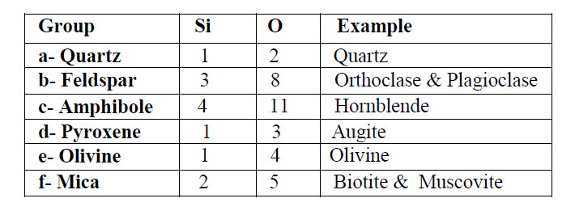
Table (3.1). Silicate minerals groups.
2- Non silicate Minerals They are often called ore - forming minerals and they are subdivided into the following groups:
1- Native Elements: Sulphur (S), diamond (C) .
2- Oxides: Hematite (Fe2O3), magnetite (Fe3O4).
3- Carbonates: Cacite (CaCO3), dolomite [Ca,Mg (CO3) 2].
4- Sulphates: Anhydrite (CaSO4), gypsum (CaSO4 .2H2O) .
5- Sulphides: Galena (PbS), pyrite (FeS2) .
6- Phosphates: Apatite [Ca,F(PO4) 3] .
7- Florides: Fluorite (CaF2).
8- Chlorides: Halite (NaCl).
3- Clay Minerals They are hydrous alumina silicates originate as products of the chemical weathering of the other silicate minerals. Clay minerals are also important rock forming minerals since they constitute shales and make up a large percentage of the soil. Because of the importance of soil in agriculture and as a supporting material for buildings, clay minerals are extremely important to for geologists and civil engineers.
Crystal Forms of Minerals:
A crystal is defined as a polyhedral form bounded by plane surfaces (faces) that reflects the orderly internal arrangement of atoms with a specific crystal form and constant angles and ordered in special systems.
Crystals properties: They are depending on:
1-Crystal faces: Are the surfaces that define the shape of the crystal which is mostly flat, and rarely to be convex or concave. Indicate these surfaces on a regular atomic arrangement engineering firm.\
2- Crystal angles:
a-Edge angle: It is an angle between two neighbor faces.
b-Interfacial angle: It is an angle between two faces; it can be measured by two perpendicular columns on neighbor and opposite faces.
c-Solid angle: It is an angle between three neighbor faces.

3- Crystal form: They are similar surface of the crystal consists of each type of face or two faces and at least one related to the crystal axes.

Crystal symmetry: It is a phenomenon of the formation of a regular crystal form depending on the arrangement of atoms and ions of the constituent material in accordance with the coordination of certain natural, and show to the symmetry repetitive exchange aspects of the body as per their positions to take the crystal single-mode twice or more if they are administered in the crystal full cycle around the axis given.
Elements of symmetry: Are signs of a fake attributed to the crystal symmetry, a point or line or level, single or combined, as follows:
1- Plane of symmetry.
2- Axis of symmetry.
3- Center of symmetry.
4- Inversion axis of symmetry.
1- Plane of symmetry: It is the plane at which the crystal is divided into two equal halves, each half a mirror image of the other.
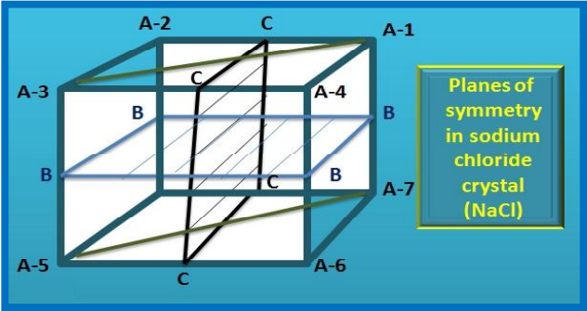
Fig (3.1)
2- Axis of symmetry: It is an imaginary line pass through crystal center. If the crystal is rotated around that line (360°), face, edge and any line of crystal repeat its self twice or more.
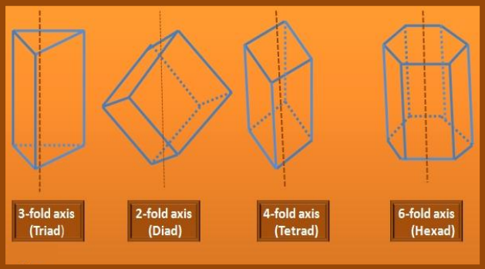
Fig (3.2)
3- Center of symmetry: It is a central imaginary point into crystal, That's where the distance of face, edge, and angle in certain side are equal to the other in opposite side from the center.

Crystallographic axes: Imaginary lines intersect within the crystal in its traditional downstream and up to different indications described for it place the crystal facets, each face more cuts at the center or at a distance from the center, which is normally three axes: a. b. c.
Axis a: It is the line that extends vertically in a reading from the crystal examined.
Axis b: is the axis that runs parallel to the development of reading for those who examine the crystal.
Axis c: Are the vertical axes, which are more axes mostly uniform.

