4-Rocks:
Rocks are aggregates of one or more mineral.
The nature and properties of a rock are determined by the minerals in it.
(particularly those essential minerals which individually make up more than 95% of its volume) .
- According to their manner formation, or genetic classification, rocks are three main types:
1-Igneous rocks: are formed from magma, which has originated well below the surface, and has crystallized as solid rock either on the surface or deep within the earth’s crust as its temperature.

2-Sedimentary rocks: are formed by the accumulation and compaction of;
fragments from pre-existing rocks which have been disintegrated by erosion ;
organic debris such as shell fragments or dead plants; or material dissolved in surface waters (rivers, oceans, etc.) or ground water, which is precipitated in conditions of oversaturation.

3-Metamorphic rocks: are formed from pre-existing rocks of any type, which have been subjected to increases of temperature (T) or pressure (P) or both, such that the rocks undergo change. This change results in the metamorphic rock being different from the original parental material in appearance, texture and mineral composition.

1-Igneous Rocks:
- Igneous rocks represent about 25% of earth surface rocks but 95% of earth crust rocks.
- Those rocks formed by cooling and solidification of hot molten mineral matter, known Magma below the surface of the earth.
- If this material comes to the earth surface, it is termed as lava which is similar to magma except that most of the gaseous component has escaped.
- The process by which crystals are formed after cooling is call crystallization.
- The rocks which result when lava solidifies are classified as extrusive, or volcanic.
- The magma is not able to reach the surface crystallizes at depth and producing intrusive, or plutonic rocks.

- Igneous Rocks Structures:
1-Extrusive Rocks:
Extrusive rocks are formed when molten rock (magma) reaches the surface, along either wide vertical fissures or pipe-like openings in the earth’s crust.
columnar joints resulted from contraction due to cooling.
pillows when lava flows under water.
2-Intrusive (Plutonic) Rocks
Intrusive Igneous structures and forms are classified into two main categories with respect to depth:

a-Hyabyssal Rocks Rocks that are formed at an intermediate depths between volcanic and plutonic of fine-, medium-grained size which include.
The common hypabyssal intrusions (Fig. 4.3) are sheet-like in form, with widths usually between 1 and 70 m. They are labelled according to whether or not they conform to the structure of the strata in which they are emplaced:
1-Sills: A concordant hypabyssal intrusion injected along the layering in the country rocks is called a sill. Most sills are subhorizontal, so the terms are often used loosely with this relative orientation in mind.
2-Dykes: A discordant hypabyssal intrusion cutting steeply across the layering is called a dyke and most dykes are near-vertical.
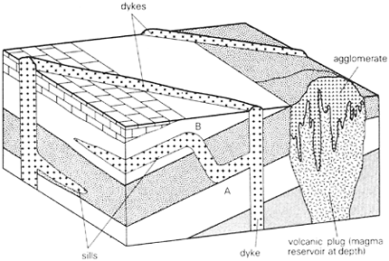
Fig.(4.3). The common types of hypabyssal intrusion: a volcanic plug, a sill and a dyke are shown in sections and on the surface.
b-Structures and Forms of Intrusive ( Plutonic ) Rocks at greater depths: These structures and forms are formed at greater depths under high temperature and pressure resulted in coarse-grained rocks, some of these structures are:
1-Laccolith: The smallest intrusions are often mushroom-shaped with a flat base and an upwards bulging roof, similar to sills but with restricted movement of magma because the that generates laccolith magma is believed to be quite viscous.
2-Phacolith: Other forms of structures those are undulated parallel to fold layers with lens-shaped mass.
3-Lopolith : Sheets of this type are a few kilometers thick, often down- warping the underlying original rocks because of the weight of magma involved.
4-Batholith : The major plutonic intrusion which is a great body , always formed from acid magma, and it is characteristic of late igneous activity in mobile belts. For its largeness, different believes have been introduced for its origin (Fig. 4.4).

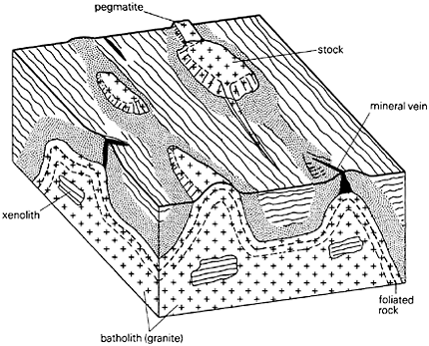

Fig. (4.4). The granite of the batholith has been emplaced in country rocks.

- Classification of Igneous Rocks :
- Igneous rocks are classified according to the mode of formation, texture and composition.
1-Mode of Formation:
Volcanic: fine-grained, aphanitic, basalt, dacite, andesite, rhyolite.
Plutonic: coarse-grained, phaneritic, diorite,granite, gabbro.
Porphyritic: porphyritic andesite.
Glassy: obsidian.
The grain of plutonic rocks are a) coarse-grained b) porphyritic c) fine-grained d) aphanitic
2- Mode of Textural:
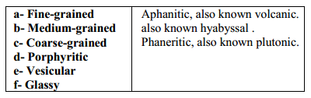
- Mineral Composition
Igneous rocks are subdivided according to their mineral composition into:
a- Acidic: Sialic-silica and aluminan, light color, its mineral composition is
mainly feldspar (orthoclase, plagioclase) and quartz, e.g. granite rock.
b- Intermediate: It lies between acidic and basic, intermediate in color , its
composition is mainly feldspar and little quartz, e.g. andesite rock.
c- Basic: Simatic-silica and magnesia, dark color, its mineral composition is
mainly biotite, pyroxene, amphiboles, e.g. gabbro rock.
d- Ultra-Basic: Ferromagnesian minerals are predominant without quartz,
e.g. olivinite rock.

