وزارة التعليم العالي والبحث العلمي  كلية المستقبل الجامعة  قسم: الهندسة الكيمياوية والصناعات النفطية  مختبر/علوم وهندسة المواد |  | رمز السجل :  تاريخ الإصدار:  رقم الإصدار:
 |  | المرحلة : الثانية
 | سجل التجارب للعام الدراسي 2020 - 2021

رقم التجربة:- (1)
اسم التجربة:-- Tensile test
الغرض من التجربة:- To obtain a general understanding of how material behave under tensile loading-
-Demonstrate the relationship between stress and strain to deter mine the tensile properties of a material from the results
الأجهزة والمعدات:-

Eequipment and Tools

Tensile specimen
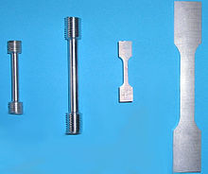
The preparation of test specimens depends on the purposes of testing and on the governing test method or specification. A tensile specimens is usually a standardized sample cross-section. It has two shoulders and a gage (section) in between. The shoulders are large so they can be readily gripped, whereas the gauge section has a smaller cross-section so that the deformation and failure can occur in this area.[2][4]
The shoulders of the test specimen can be manufactured in various ways to mate to various grips in the testing machine (see the image below). Each system has advantages and disadvantages; for example, shoulders designed for serrated grips are easy and cheap to manufacture, but the alignment of the specimen is dependent on the skill of the technician. On the other hand, a pinned grip assures good alignment. Threaded shoulders and grips also assure good alignment, but the technician must know to thread each shoulder into the grip at least one diameter's length, otherwise the threads can strip before the specimen fractures.[5]
In large castings and forgings it is common to add extra material, which is designed to be removed from the casting so that test specimens can be made from it. These specimens may not be exact representation of the whole workpiece because the grain structure may be different throughout. In smaller workpieces or when critical parts of the casting must be tested, a workpiece may be sacrificed to make the test specimens.[6] For workpieces that are machined from bar stock, the test specimen can be made from the same piece as the bar stock.
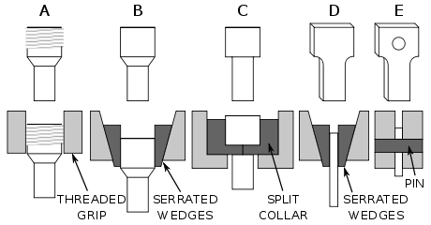
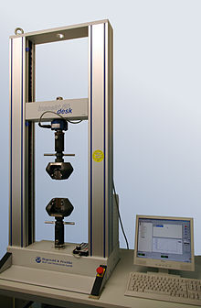

: - Tensile Test Experiment
One material property that is widely used and recognized is the strength of a material. But what does the word "strength" mean? "Strength" can have many meanings, so let us take a closer look at what is meant by the strength of a material. We will look at a very easy experiment that provides lots of information about the strength or the mechanical behavior of a material, called the tensile test.
The basic idea of a tensile test is to place a sample of a material between two fixtures called "grips" which clamp the material. The material has known dimensions, like length and cross-sectional area. We then begin to apply weight to the material gripped at one end while the other end is fixed. We keep increasing the weight (often called the load or force) while at the same time measuring the change in length of the sample.
- Tensile Test
One can do a very simplified test at home.
If you have a way to hang one end of some material from a solid point that does not move, then you can hang weights on the other end.
Measure the change in length while adding weight until the part begins to stretch and finally breaks.
The result of this test is a graph of load (amount of weight) versus displacement (amount it stretched). Since the amount of weight needed to stretch the material depends on the size of the material (and of course the properties of the material), comparison between materials can be very challenging. The ability to make a proper comparison can be very important to someone designing for structural applications where the material must withstand certain forces.
- Cross-Sectional Areas
We need a way of directly being able to compare different materials, making the “strength” we report independent of the size of the material. We can do that by simply dividing the load applied to the material (the weight or force) by the initial cross-sectional area. We also divide the amount it moves (displacement) by the initial length of the material. This creates what material scientists refer to as engineering stress (load divided by the initial cross-sectional area) and engineering strain (displacement divided by initial length). By looking at the engineering stress-strain response of a material we can compare the strength of different materials, independently of their sizes.
To use the stress-strain response for designing structures, we can divide the load we want by the engineering stress to determine the cross-sectional area needed to be able to hold that load. For example, a 1/8” diameter 4340 steel wire can hold a small car. Again, it is not always that simple. We need to understand the different meanings of “strength” or engineering stress.
Now it gets more complicated. Let us take a look at what is meant by the different strength values and also look at other important properties we can get from this simple test. The easiest way is to examine a graph of engineering stress versus engineering strain. Shown below is a graph of a tensile test for a common steel threaded rod, providing a good example of a general metal tensile test. The units of engineering stress are ksi, which stands for a thousand pounds per square inch. Note the reference to area in the units. The units on strain are of course unitless, since we are dividing distance by distance.
-----------------------------------------------------------------------------------------------------------------------------------------------------------------------النتائج القياسية :-
Type specimen | United States(ASTM) | Britain | Germany
Sheet ( Lo / √Ao) | 4.5 | 5.65 | 11.3
Rod ( Lo / Do) | 4.0 | 5.00 | 10.0
The following tables gives examples of test specimen dimensions and tolerances per standard ASTM E8.
Flat test specimen[7]
All values in inches | Plate type (1.5 in. wide) | Sheet type (0.5 in. wide) | Sub-size specimen (0.25 in. wide)
Gauge length | 8.00±0.01 | 2.00±0.005 | 1.000±0.003
Width | 1.5 +0.125–0.25 | 0.500±0.010 | 0.250±0.005
Thickness | 0.188 ≤ T | 0.005 ≤ T ≤ 0.75 | 0.005 ≤ T ≤ 0.25
Fillet radius (min.) | 1 | 0.25 | 0.25
Overall length (min.) | 18 | 8 | 4
Length of reduced section (min.) | 9 | 2.25 | 1.25
Length of grip section (min.) | 3 | 2 | 1.25
Width of grip section (approx.) | 2 | 0.75 | ​³⁄₈

Round test specimen[7]
All values in inches | Standard specimen at nominal diameter: |  | Small specimen at nominal diameter:
 | 0.500 | 0.350 | 0.25 | 0.160 | 0.113
Gauge length | 2.00±0.005 | 1.400±0.005 | 1.000±0.005 | 0.640±0.005 | 0.450±0.005
Diameter tolerance | ±0.010 | ±0.007 | ±0.005 | ±0.003 | ±0.002
Fillet radius (min.) | ​³⁄₈ | 0.25 | ​⁵⁄₁₆ | ​⁵⁄₃₂ | ​³⁄₃₂
Length of | 2.5 | 1.75 | 1.25 | 0.75 | ​⁵⁄₈

Conclusions and discussion
Draw stress _ strain curve? -
What is necking?-
Define plastic deformation? -

